Technical Design Specification

**OCBC Bank**

**Prepared by:**

**iZeno Pte. Ltd.**

Copyright © 2023. iZeno Pte. Ltd. All rights reserved.

Reproduction or disclosure in whole or in parts to parties other than the client is NOT permitted unless written consent is obtained.



**Document Control**

|  |  |  |  |
| --- | --- | --- | --- |
| Project Name: | OCBC - BOS DevOps Tool Migration | | |
| Project Manager: | Verlyn Goo | Document Version No: | 1.6 |
| Prepared By: | Tan Zhi Min | Document Version Date: | 13 Oct 2023 |

**Reviewed By**

|  |  |  |  |
| --- | --- | --- | --- |
| Name | Role/Department | Date | Signature |
|  |  |  |  |

**Version History**

|  |  |  |  |
| --- | --- | --- | --- |
| Ver. No. | Ver. Date | Revised By | Description |
| 1.0 | 15 Sep 2023 | iZeno | Initial version |
| 1.1 | 19 Sep 2023 | iZeno | Updated Section 5, 6, 8. Added Appendix |
| 1.2 | 21 Sep 2023 | iZeno | Added Section 4.1.2. Updated Section 5, 6 and Appendix |
| 1.3 | 27 Sep 2023 | iZeno | Remove Section 4.1.3 , omit version 7.8 details to be put in the appendix as an upgrade detail.  Add appendix to verify the conflicting item and the add on usage  Add procedure to do a post migration testing for final add on list for migration  Add procedure for add on migration |
| 1.4 | 4 Oct 2023 | iZeno | Removed Appendix section  Updated Jira Migration section to use Configuration Manager for Jira to do the migration |
| 1.5 | 9 Oct 2023 | iZeno | Added 3.1.2 with the OCBC Jira Prod add-ons details  Updated section 5.2 and 5.3  Updated 6.2.2 with the BOS Nexus repo details |
| 1.6 | 13 Oct 2023 | iZeno | Updated 4.2 with the BOS Nexus repo data  Updated Jira migration section with method to transfer attachments data  Updated Nexus migration section with method to transfer repo data |

**Table of Contents**

**1. Introduction 5**

1.1 Background 5

1.2 Objectives 5

1.3 Scope 5

**2. Tools Introduction 7**

2.1 Jira Software 7

2.2 Nexus Repository 8

2.3 BitBucket by Atlassian 9

2.4 Jenkins 10

**3. Overview of Current OCBC Environment 11**

3.1 Jira Software 11

3.1.1 Jira Add-ons in UAT 12

3.1.2 Jira Add-ons in Production 13

3.2 Nexus Repository 14

3.2.1 Repositories 15

3.2.2 Blob stores 16

3.2.3 Cleanup Policies 16

3.2.4 Roles 17

3.2.5 Users 17

**4. Overview of Current BOS Environment 19**

4.1 Jira Software 19

4.1.1 Initial Jira version 19

4.1.2 Upgraded Jira version 20

4.2 Nexus Repository 22

4.2.1 Repositories 23

4.2.2 Blob stores 23

4.2.3 Cleanup Policies 24

4.2.4 Roles 24

4.2.5 Users 24

4.3 Bitbucket 25

4.4 Jenkins 25

**5. Jira Migration Process 26**

5.1 Prerequisites 26

5.2 Migration Procedure 27

5.2.1 Pre-Migration Procedure 27

5.2.2 Migration Procedure 35

5.2.3 Post-Migration Procedure 42

5.3 Add-On Data Migration 57

5.3.1 ScriptRunner Add-On Data Migration 58

5.3.2 Zephyr Squad Add-On Data Migration 58

5.3.3 Time in Status Data Migration 59

5.3.4 JBehave for Jira Data Migration 59

5.3.5 Multiple Filters Chart Gadget 60

5.3.6 Easy Agile User Story Maps for Jira Data Migration 60

5.3.7 UpRaise for Employee Success Data Migration 61

5.4 Rollback procedure 62

**6. Nexus Migration Process 64**

6.1 Prerequisites 64

6.2 Migration Procedure 65

6.2.1 Pre-Migration Procedure 65

6.2.2 Migration Procedure 69

6.2.3 Post-migration Procedure 74

**7. Bitbucket Reconfiguration 75**

7.1 Prerequisites 75

7.2 Configuration Steps 75

**8. Jenkins Reconfiguration 82**

8.1 Prerequisites 82

8.2 Configuration Steps 82

**9. Migration Runbook Schedule 88**

# 

# 

# 

# Introduction

This document is used to document the technical design and requirements related to migration and merger of selected DevOps Tool from Bank of Singapore (BOS) environment into OCBC Bank (OCBC) environment. This should be used in conjunction with the scope documented in the Statement of Work (SOW).

This document also serves as a guide to development and testing throughout the project.

## Background

Bank of Singapore was acquired by OCBC Bank in 2009. Each bank has their own DevOps framework and instances to meet individual business requirements. In order to foster collaboration and enhance the productivity from the business operations, it is important to have a joint single DevOps model for Bank of Singapore and OCBC Bank.

## Objectives

The scope of this project is aiming to achieve the following primary objectives:

* Migrate BOS Jira to OCBC Jira
* Migrate BOS Nexus to OCBC Nexus
* Reconfigure Nexus URL in BOS Bitbucket
* Reconfigure Nexus URL in BOS Jenkins
* Warranty Support (minimal one month)

## Scope

The scope of work for this project is as follows:

* Analysis and Design
  + Assess the requirements and prerequisites
  + Document the Design and assumptions
  + Conduct Technical Design Workshops
* Small-scale Implementation
  + Test-run and debug Python scripts
  + Perform Jira Migration in UAT at a small scale (~12 projects)
  + Perform Nexus Migration in UAT at a small scale (~ 3 repositories)
* Full-scale Implementation
  + Run Python scripts in UAT
  + Perform full-scale Jira Migration in UAT
  + Perform full-scale Nexus Migration in UAT
* User Acceptance Test
  + Bitbucket and Jenkins changes
  + Nexus Repositories
  + Jira Software Projects
* Production Implementation and Project Transition
  + Run Python scripts in Production
  + Perform full-scale Jira Migration in Production
  + Perform full-scale Nexus Migration in Production
* Post Implementation Transition
  + Fulfillment of Warranty period (minimal one month)

# 

# 2. Tools Introduction

## 2.1 Jira Software

Jira Software is a software development tool used by agile teams – with customizable requirement types, workflows, permissions, and notifications. It provides virtual scrum and kanban boards for teams to collaboratively and visually manage backlogs, track the progress of work, and use real-time reports. IT teams can use Jira Software to organize large change management projects and problem management initiatives, or with even routine maintenance tasks. This is especially helpful for teams who organize their work in sprints or want to visualize their tasks to be done with scrum and kanban boards.

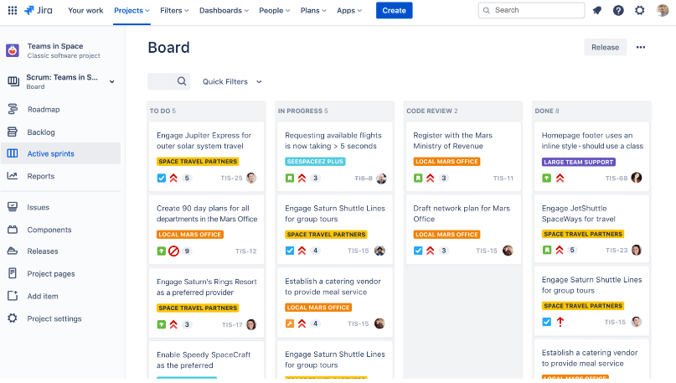

Each project can have its own configurable Workflows, Issue types, Screens, Custom fields and Priorities. This enables Project Administrators to customize the project according to the project requirements and business scenarios.

## 

## 2.2 Nexus Repository

Nexus by Sonatype is a repository manager that organises, stores and distributes artifacts needed for software development. It provides developers the capability to control access to, and deployment of, every artefact in an organisation from a single location. IT teams can use Sonatype Nexus repository as a central platform for storing build artifacts, which will help to optimize build performance and storage costs. This is beneficial for large organizations as they can improve efficiency across teams.

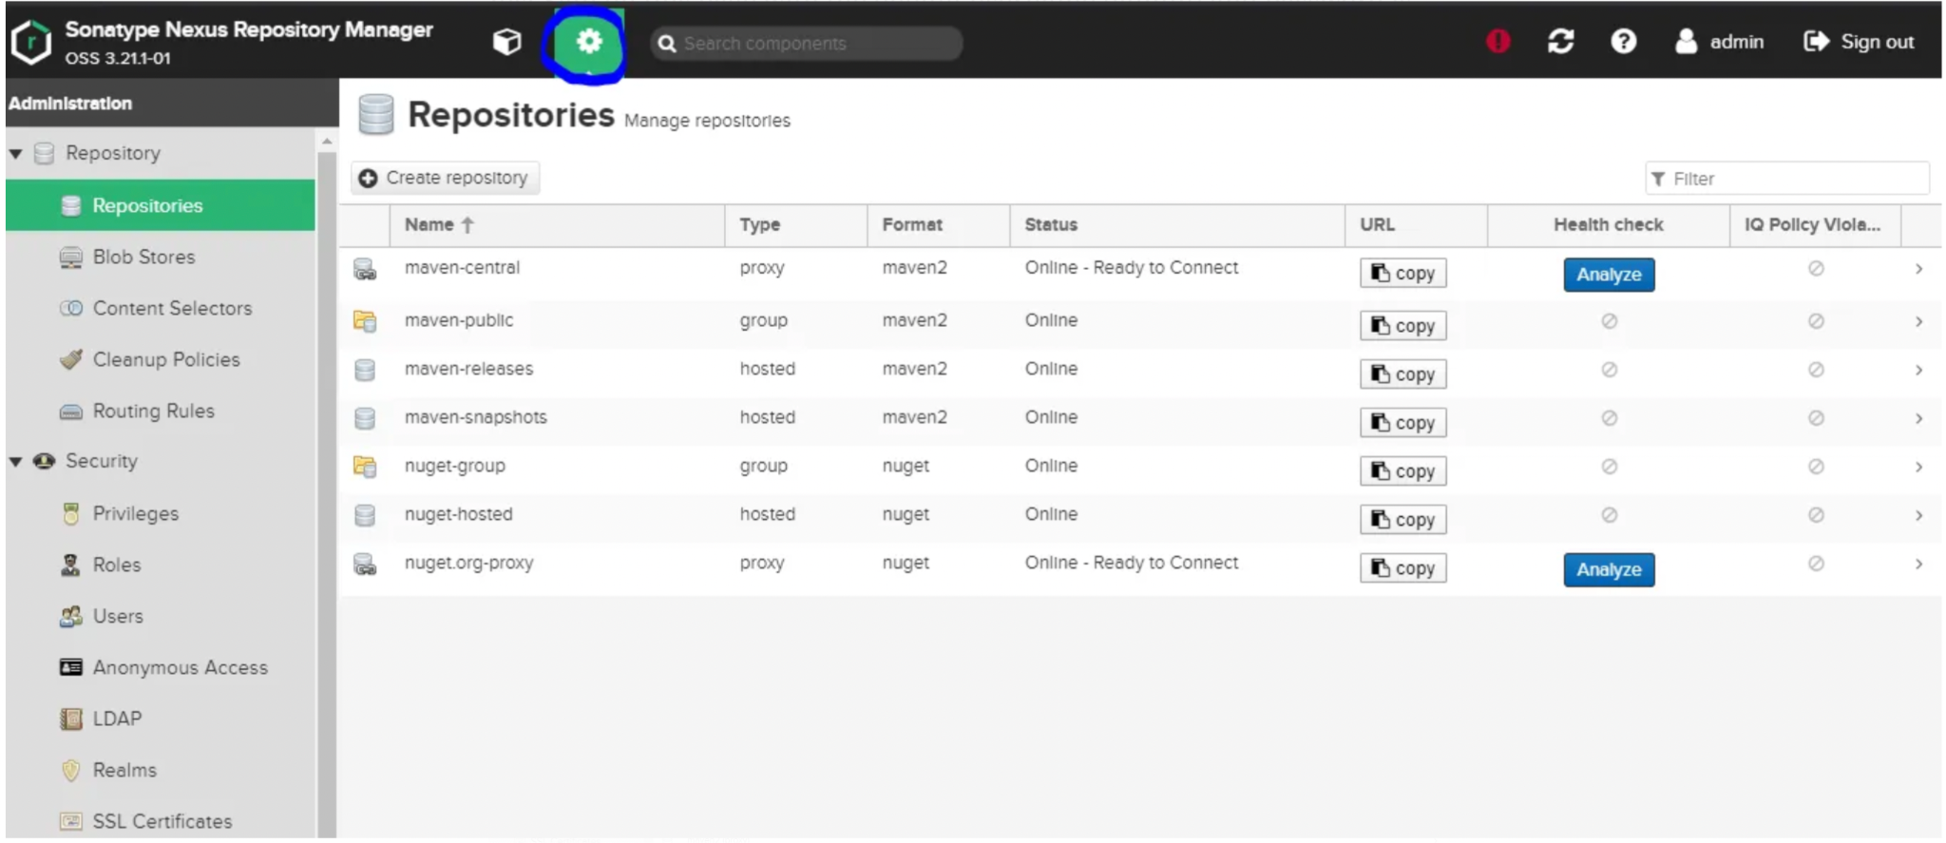

The binary assets that users download via proxy repositories, or publish to hosted repositories, are stored in the blob store attached to those repositories.

Cleanup policies can be used to remove content from the repositories, at a configurable frequency. Once created, a cleanup policy must be associated with a repository.

## 2.3 BitBucket by Atlassian

Bitbucket by Atlassian is a Git-based source code repository and CI/CD tool that is optimised for teams using Jira. With the built-in Jira UI, teams can manage their Jira issues in Bitbucket and keep track of code changes, thereby improving visibility and transparency of the build process. Using Bitbucket Pipelines, developers can easily setup and configure CI/CD with language specific templates, as well as build automated workflows. This helps reduce context-switching and allows teams to store and manage their entire development workflow in a single place, enabling continuous delivery.

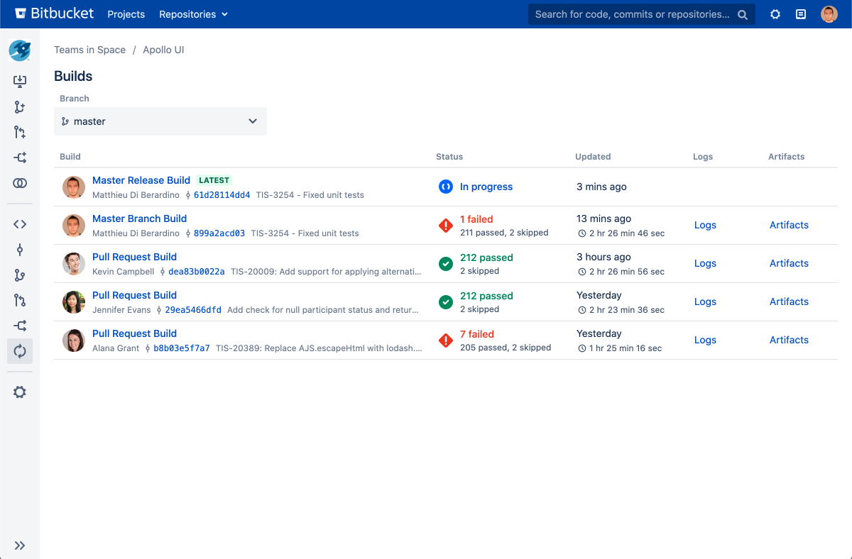

## 

## 2.4 Jenkins

Jenkins is a Java-based open-source automation platform and can be used as a CI/CD solution. It helps automate parts of the software development process related to building, testing and deploying. Developers can leverage on the feature of Jenkins’ automatic job management to automatically create, update and delete jobs based on the repositories it identified in the software configuration management. By writing the definition of a Jenkins Pipeline into a Jenkinsfile and in turn committing it to a project’s source code repository, this automatically creates a Pipeline build process for all branches and pull requests, which can be used by all members of the project.

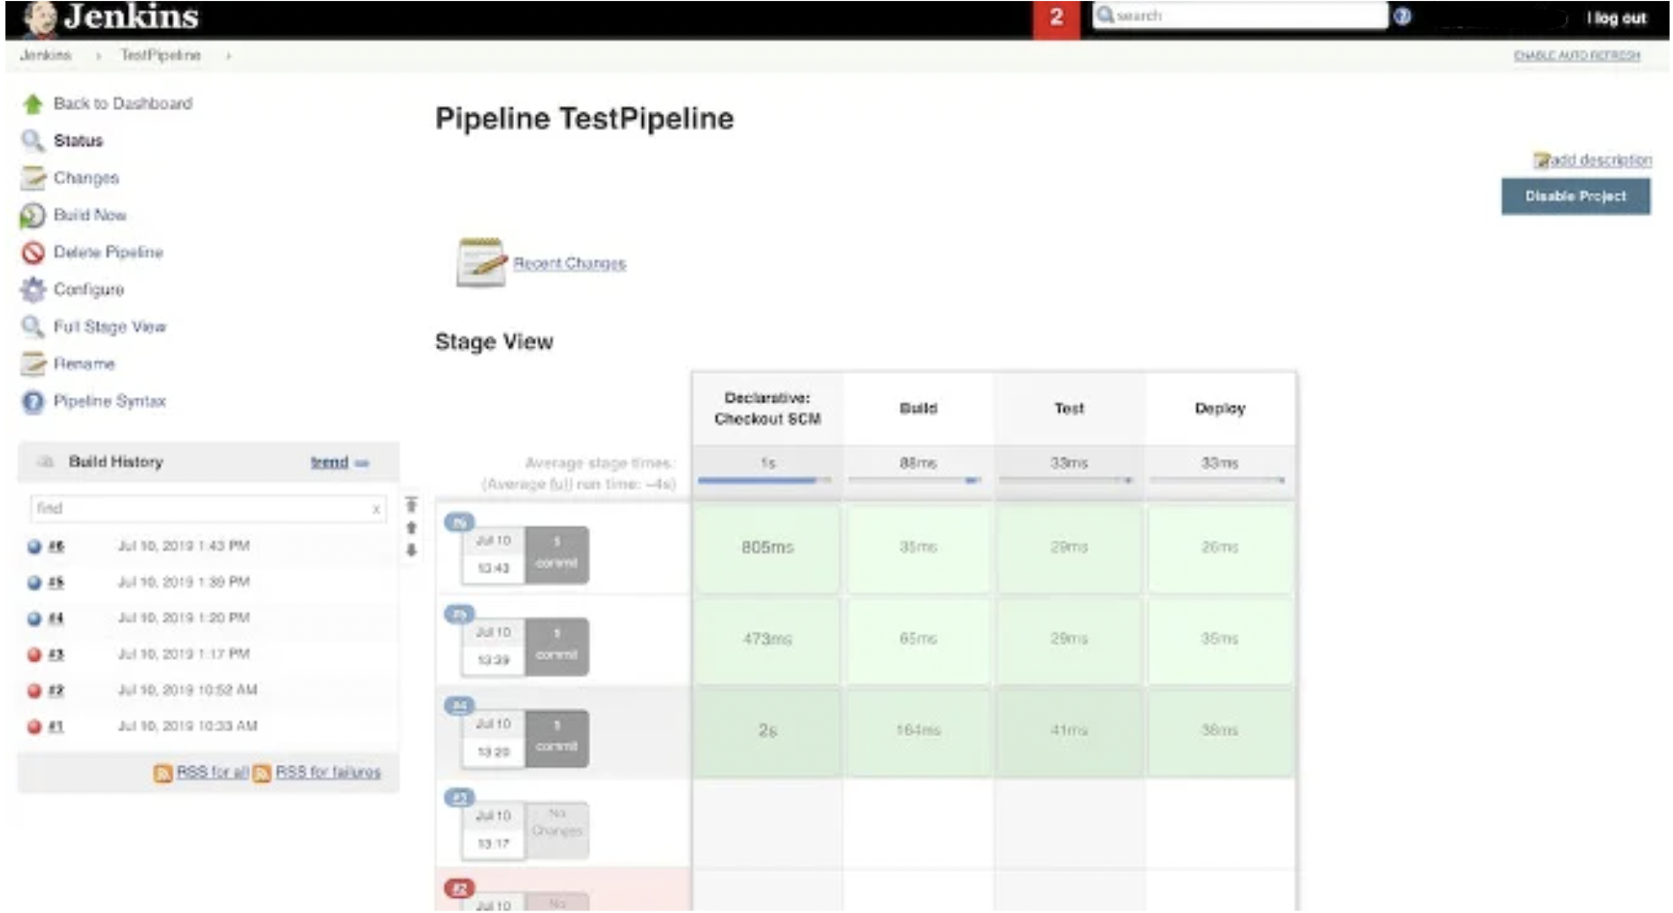

# 3. Overview of Current OCBC Environment

## 3.1 Jira Software

There are two available environments: UAT and Production.

* UAT environment - Jira version 9.6.0 (Developer license, Data Center)
* Production environment - Jira version 9.6.0 (Developer license, Data Center)

|  |  |  |
| --- | --- | --- |
| Composition | UAT Jira | Prod Jira |
| Server Info | Operating System: Linux 3.10.0-1160.95.1.el7.x86_64  Database type: postgres72  Database version: 14.7.0  Database driver: PostgreSQL JDBC Driver 42.2.25 | Operating System: Linux 4.18.0-477.21.1.el8_8.x86_64  Database type: postgres72  Database version: 14.7.0  Database driver: PostgreSQL JDBC Driver 42.2.25 |
| Java VM Memory Statistics | Total Memory: 4096 MB  Available Memory: 932 MB (23% Free) | Total Memory: 16384 MB  Available Memory: 4033 MB (24% Free) |
| Database Statistics | Total Projects: 1183  Archived Projects: 152  Total Issues: 2057703  Archived Issues: 200799  Custom Fields: 1328  Issue Types: 249  Attachments: 1194264  Screen Schemes: 2816  Users: 15436  Groups: 12950  Workflows: 995  Priorities: 9 | Total Projects: 1224  Archived Projects: 165  Total Issues: 2288493  Archived Issues: 69876  Custom Fields: 1395  Issue Types: 259  Attachments: 1367678  Screen Schemes: 2915  Users: 16609  Groups: 14059  Workflows: 1033  Priorities: 9 |

### 

### 3.1.1 Jira Add-ons in UAT

The list of enabled Jira Add-ons is listed in the table below.

|  |  |
| --- | --- |
| Add-on | Description |
| Adaptavist ScriptRunner for Jira | Version: 7.12.0  License: 10000-user developer license, Data Center, expires 31/Mar/24  License Status: Valid |
| Jira Command Line Interface (CLI) | Version: 10.6.0  License: 10000-user developer license, Data Center, expires 31/Mar/24  License status: Valid |
| Jira Toolkit Plugin | Version: 1.0.0 |
| Manage Inactive Users for Jira | Version: 1.4.9  License: 10000-user developer license, Data Center, expires 31/Mar/24  License status: Valid |
| Microsoft Teams for Jira Server | Version: 2023.03.114 |
| Time In Status | Version: 4.30.0.750  License: 10000-user developer license, Data Center, expires 31/Mar/25  License status: Valid |
| Zephyr Squad | Version: 9.2.2.92209740  License: 10000-user developer license, Data Center, expires 31/Mar/24  License status: Valid |

## 

### 3.1.2 Jira Add-ons in Production

The list of enabled Jira Add-ons is listed in the table below.

|  |  |
| --- | --- |
| Add-on | Description |
| Adaptavist ScriptRunner for Jira | Version: 7.12.0  License: 10000-user commercial license, Data Center, expires 31/Mar/24  License Status: Valid |
| Jira Command Line Interface (CLI) | Version: 10.6.0  License: 10000-user commercial license, Data Center, expires 31/Mar/24  License status: Valid |
| Jira Toolkit Plugin | Version: 1.0.0 |
| Manage Inactive Users for Jira | Version: 1.4.9  License: 10000-user commercial license, Data Center, expires 31/Mar/24  License status: Valid |
| Microsoft Teams for Jira Server | Version: 2023.03.114 |
| Time In Status | Version: 4.30.0.750  License: 10000-user commercial license, Data Center, expires 31/Mar/25  License status: Valid |
| Zephyr Squad | Version: 9.2.2.92209740  License: 10000-user commercial license, Data Center, expires 31/Mar/24  License status: Valid |

## 3.2 Nexus Repository

There are two available environments: UAT and Production.

* UAT environment - Nexus version 3.46.0-01, with Pro license.
* Production environment - Nexus version 3.46.0-01, with Pro license.

|  |  |
| --- | --- |
| Composition | UAT Nexus |
| Configuration | installDirectory: /apps/nexus/nexus-3.46.0-01  workingDirectory: /apps/nexus/sonatype-work/nexus3  temporaryDirectory: /apps/nexus/sonatype-work/nexus3/tmp |
| Status |  |

|  |  |
| --- | --- |
| Composition | Prod Nexus |
| Configuration | installDirectory: /apps/nexus/nexus-3.46.0-01  workingDirectory: /apps/nexus/sonatype-work/nexus3  temporaryDirectory: /apps/nexus/sonatype-work/nexus3/tmp |
| Status |  |

### 

### 3.2.1 Repositories

The snippet view of the repositories present in UAT is:

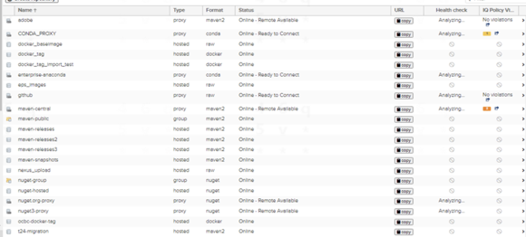

The snippet view of the repositories present in Production is:

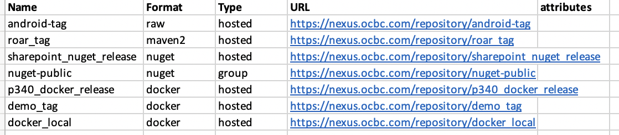

### 3.2.2 Blob stores

The snippet view of the blob stores present in UAT is:

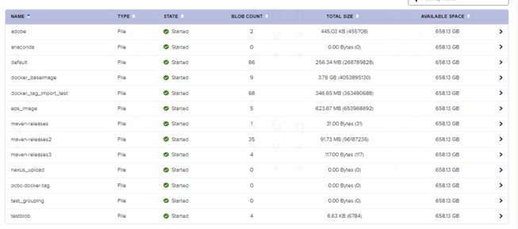

The snippet view of the blob stores present in Production is:

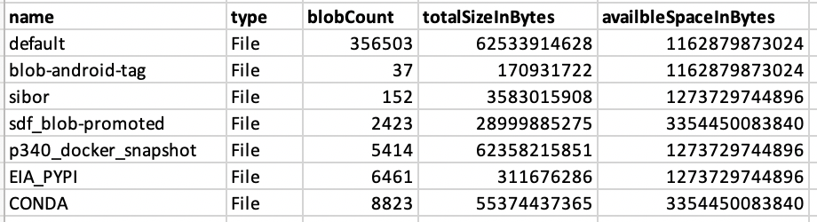

### 3.2.3 Cleanup Policies

The snippet view of the cleanup policies present in UAT is:

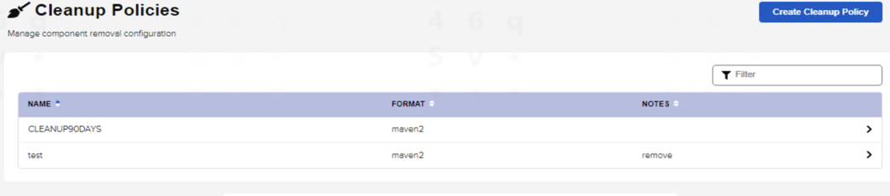

### 3.2.4 Roles

The snippet view of the roles present in UAT is:

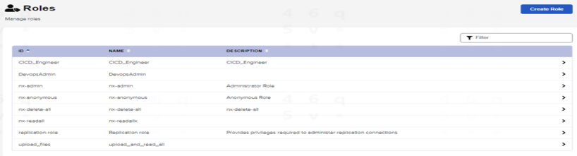

The snippet view of the roles present in Production is:

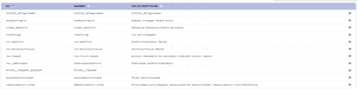

### 3.2.5 Users

The snippet view of the local users present in UAT is:

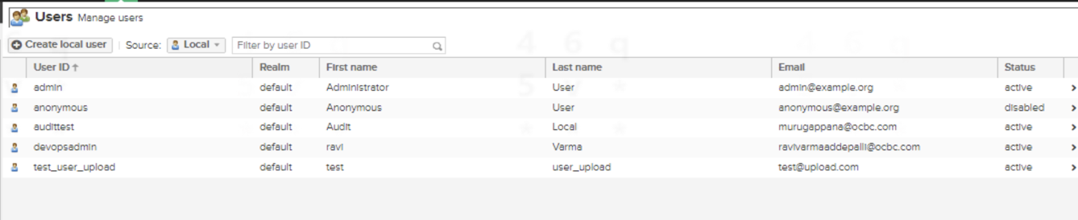

The snippet view of the local users present in Production is:

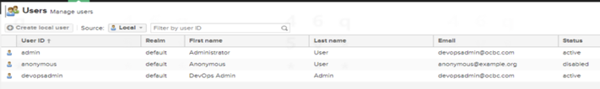

# 4. Overview of Current BOS Environment

## 4.1 Jira Software

There is only one environment - Production environment.

### 4.1.1 Initial Jira version

The initial Jira version, before the upgrade, was 7.8.0 (server).

|  |  |
| --- | --- |
| Composition | Jira v7.8.0 instance |
| Server Info | Operating System: Windows Server 2012 R2 6.3  Database type: mssql  Database version: 12.00.6444  Database driver: Microsoft JDBC Driver 6.2 for SQL server 6.2.1.0 |
| Java VM Memory Statistics | Total Memory: 4069 MB  Available Memory: 553 MB (14% Free) |
| Database Statistics | Total Projects: 183  Total Issues: 132192  Custom Fields: 357  Issue Types: 65  Attachments: 154617  Screen Schemes: 167  Users: 115769  Groups: 27734  Workflows:86  Priorities: 10 |

|  |  |
| --- | --- |
| Add-ons | Description |
| Adaptavist ScriptRunner for Jira | Version: 5.2.1  License: 2000-user commercial license, Standard, expires 14/Feb/24  License status: Valid |
| Easy Agile User Story Maps for Jira | Version: 4.0.8  License: 2000-user commercial license, Standard, expires 16/Jul/23  License status: Valid |
| JBehave for Jira | Version: 5.0.4  License: 2000-user commercial license, Standard, expires 14/Feb/24  License status: Valid |
| Multiple Filters Chart Gadget | Version: 4.7.2  License: 2000-user commercial license, Standard, expires 14/Feb/24  License: Valid |
| Time In Status | Version: 4.3.6.626  License: 2000-user commercial license, Standard, expires 14/Feb/24  License status: Valid |
| UpRaise for Employee Success | Version: 4.0.0.0  License: 2000-user commercial license, Standard, expires 14/Feb/24  License status: Valid |
| ZAPI | Version: 2.7.1.27107788 Part of Zephyr (API Integration) |
| Zephyr for Jira | Version: 4.0.2.40207614  License: 2000-user commercial license, Standard, expires 14/Feb/24  License status: Valid |

### 4.1.2 Upgraded Jira version

The current Jira version, after the upgrade, is 8.5.0 (server).

|  |  |
| --- | --- |
| Composition | Jira v8.5.0 instance |
| Server Info | Operating System: Windows Server 2012 R2 6.3  Database type: mssql  Database version: 12.00.6444  Database driver: Microsoft JDBC Driver 7.2 for SQL server 7.2.1.0 |
| Java VM Memory Statistics | Total Memory: 2007 MB  Available Memory: 423 MB (21% Free) |
| Database Statistics | Total Projects: 184  Total Issues: 135809  Custom Fields: 357  Issue Types: 65  Attachments: 159440 (rough size - 88.6GB)  Screen Schemes: 161  Users: 115755  Groups: 27734  Workflows:87  Priorities: 10 |

The list of enabled Jira Add-ons is listed in the table below.

|  |  |
| --- | --- |
| Add-ons | Description |
| Adaptavist ScriptRunner for Jira | Version: 6.38.0  License: 2000-user commercial license, Standard, expires 14/Feb/24  License status: Valid |
| Easy Agile User Story Maps for Jira | Version: 4.0.8  License: 2000-user commercial license, Standard, expires 16/Jul/23  License status: Valid |
| JBehave for Jira | Version: 5.0.4  License: 2000-user commercial license, Standard, expires 14/Feb/24  License status: Valid |
| Multiple Filters Chart Gadget | Version: 5.15.0  License: 2000-user commercial license, Standard, expires 14/Feb/24  License: Valid |
| Time In Status | Version: 4.31.2.754  License: 2000-user commercial license, Standard, expires 14/Feb/24  License status: Valid |
| UpRaise for Employee Success | Version: 4.0.0.0  License: 2000-user commercial license, Standard, expires 14/Feb/24  License status: Valid |
| ZAPI | Version: 2.7.1.27107788 |
| Zephyr Squad | Version: 8.3.0.83009793  License: 2000-user commercial license, Standard, expires 14/Feb/24  License status: Valid |

## 4.2 Nexus Repository

There is only one environment - Production environment. The current Nexus version is 3.38.1-01. The license edition has been upgraded from OSS to PRO.

|  |  |
| --- | --- |
| Composition | Prod Nexus |
| Configuration | installDirectory: J:\CI\nexus\nexus-3.16.2-01  workingDirectory: J:\CI\nexus\sonatype-work\nexus3  temporaryDirectory: J:\CI\nexus\sonatype-work\nexus3\tmp |
| Status |  |

### 4.2.1 Repositories

The below list of 16 repositories will be migrated, with a total size of 3054.04 GB.

|  |  |  |  |  |  |  |
| --- | --- | --- | --- | --- | --- | --- |
| Repo Name | Repo Format | Repo Type | URL | Repo Size (GB) | Blobstore and size | Housekeeping Policy |
| docker-bosprivate | docker | hosted | <https://build.bos.group.intranet/nexus/repository/docker-bosprivate> | 198.8304545 | Default  1.75TB | Retains 150 days artefacts |
| t24-migration | maven2 | hosted | <https://build.bos.group.intranet/nexus/repository/t24-migration> | 0.000259933 | Default  1.75TB | No policy applied |
| releases-comlib | maven2 | hosted | <https://build.bos.group.intranet/nexus/repository/releases-comlib> | 0 | N/A  1.75TB | No policy applied |
| nuget-hosted | nuget | hosted | <https://build.bos.group.intranet/nexus/repository/nuget-hosted> | 0 | N/A  1.75TB | No policy applied |
| maven-central-extras | maven2 | hosted | <https://build.bos.group.intranet/nexus/repository/maven-central-extras> | 0.002160919 | Default  1.75TB | No policy applied |
| uat-releases | maven2 | hosted | <https://build.bos.group.intranet/nexus/repository/uat-releases> | 206.2144387 | Default  1.75TB | No policy applied |
| devRegistry | docker | hosted | <https://build.bos.group.intranet/nexus/repository/devRegistry> | 241.6871722 | Default  1.75TB | Remove components that have not been downloaded in 30 days |
| maven-releases | maven2 | hosted | <https://build.bos.group.intranet/nexus/repository/maven-releases> | 0.745612792 | Default  1.75TB | No policy applied |
| helm_repo | helm | hosted | <https://build.bos.group.intranet/nexus/repository/helm_repo> | 0.001 | Helm  2.81MB | No policy applied |
| thirdparty | maven2 | hosted | <https://build.bos.group.intranet/nexus/repository/thirdparty> | 1.236920368 | Default  1.75TB | No policy applied |
| t24-libs | maven2 | hosted | <https://build.bos.group.intranet/nexus/repository/t24-libs> | 6.666812252 | Default  1.75TB |  |
| releases | maven2 | hosted | <https://build.bos.group.intranet/nexus/repository/releases> | 2136.168267 | Default  1.75TB |  |
| snapshots | maven2 | hosted | <https://build.bos.group.intranet/nexus/repository/snapshots> | 144.0856878 | Default  1.75TB | Retain only last 10 artifacts, weekly runs to remove older than 10 days. |
| prod-releases | maven2 | hosted | <https://build.bos.group.intranet/nexus/repository/prod-releases> | 116.6298202 | Default  1.75TB | No policy applied |
| npm-storybook | raw | hosted | <https://build.bos.group.intranet/nexus/repository/npm-storybook> | 0.027744515 | Default  1.75TB | No policy applied |
| npm-private | npm | hosted | <https://build.bos.group.intranet/nexus/repository/npm-private> | 1.741206202 | Default  1.75TB | No policy applied |

.

The below list of repositories not required to migrate.

|  |  |  |  |  |  |  |
| --- | --- | --- | --- | --- | --- | --- |
| Repo Name | Repo Format | Repo Type | URL | Repo Size (GB) | Blobstore and size | Remarks |
| installers | raw | hosted | [https://build.bos.group.intranet/nexus/repository/](https://build.bos.group.intranet/nexus/repository/docker-bosprivate)installers | 70.77579725 | Default  1.75TB | Only used within DevOps team internally. |
| train-releases | maven2 | hosted | [https://build.bos.group.intranet/nexus/repository/t](https://build.bos.group.intranet/nexus/repository/t24-migration)rain-releases | 0.061390792 | Default  1.75TB | Not being used |
| tfs-releaes | maven2 | hosted | [https://build.bos.group.intranet/nexus/repository/](https://build.bos.group.intranet/nexus/repository/releases-comlib)tfs-releases | 0.001469538 | Default  1.75TB | Not being used |
| pypi-private | pypi | hosted | [https://build.bos.group.intranet/nexus/repository/](https://build.bos.group.intranet/nexus/repository/nuget-hosted)pypi-private | 0.0001 | Default  1.75TB | Not being used |
| npm-private2 | npm | hosted | [https://build.bos.group.intranet/nexus/repository/](https://build.bos.group.intranet/nexus/repository/maven-central-extras)npm-private2 | 0 | N/A | Not being used |
| npm-releases | npm | hosted | [https://build.bos.group.intranet/nexus/repository/](https://build.bos.group.intranet/nexus/repository/maven-central-extras)npm-releases | 0.005589699 | Default  1.75TB | Not being used |
| snapshot | maven2 | hosted | [https://build.bos.group.intranet/nexus/repository/snapshot](https://build.bos.group.intranet/nexus/repository/maven-central-extras) | 39.05661265 | SNAPSHOTS2  44.72GB | Not being used |

### 4.2.2 Blob stores

The snippet view of the blob stores present is shown below.

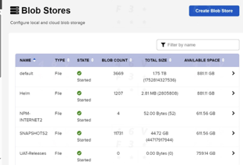

### 4.2.3 Cleanup Policies

The snippet view of the cleanup policies present is shown below.

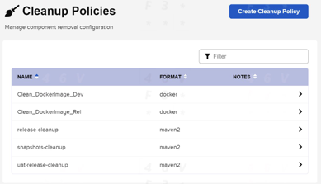

### 4.2.4 Roles

The snippet view of the roles present is shown below.

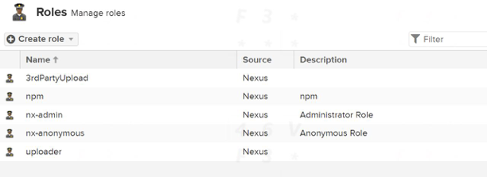

### 4.2.5 Users

The snippet view of the users present is shown below.

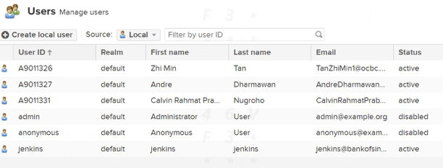

## 4.3 Bitbucket

There is only one environment - Production environment. The current Bitbucket version is v8.9.3.

## 4.4 Jenkins

There is only one environment - Production environment. The current Jenkins version is v2.176.4

# 

# 5. Jira Migration Process

Objective is to migrate Jira instance data from the BOS environment into the OCBC environment. Doing so enables:

* Better planning of Roadmaps strategically across multiple teams and projects.
* Optimisation of data management, and cleanup of old projects, unused workflows, unused custom fields.
* High level visibility and traceability of projects across the Bank environment.

## 5.1 Prerequisites

To get started, the following prerequisites need to be met:

* BOS to be on Jira v8.5.0
* Jira System Admin access to both BOS and OCBC.
* Prerequisite to transfer all attachment data:
  + Stable network connection between BOS Jira server and OCBC Jira server. Network bandwidth of 1 Gbps would be recommended.
  + Sufficient available disk space in OCBC Jira server. Minimum of 300 GB free disk space is required.

## 5.2 Migration Procedure

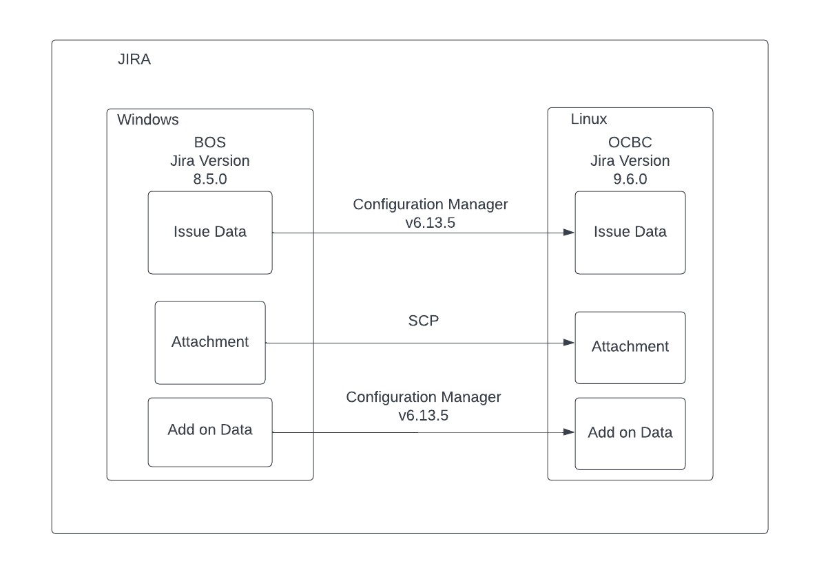

### 5.2.1 Pre-Migration Procedure

Pre-migration procedure will revolve around preparing the instances, and all the necessary data before the actual Go-Live Migration Day. Pre-migration procedure will include:

* Install Configuration Manager for Jira (CMJ) in OCBC instance and BOS instance with latest version;
* Add-on installation in the OCBC instance;
* Resolve conflict for configuration based on test result
* Blast email to all BOS Jira users to not use BOS Jira during the production migration and to confirm it is their risk to migrate during the production migration period.
* For user directory using the LDAP directory, BOS and OCBC should ensure users data is migrated before the migration, and configure the BOS user directory configuration within the OCBC directory configuration.

The current BOS Jira user directory is as follows:

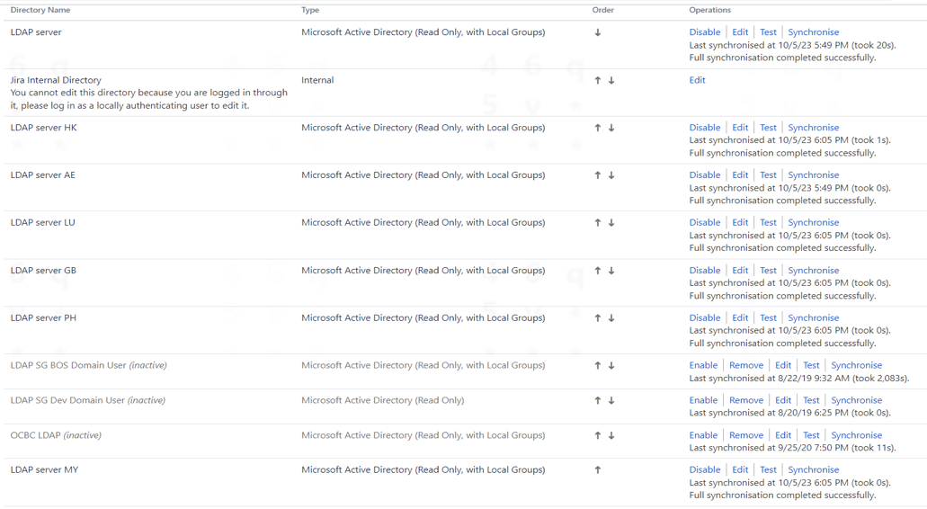

The current OCBC Jira user directory is as follows:

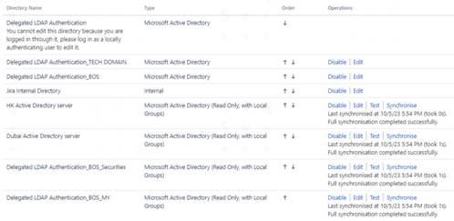

Procedure as following:

1. **Install Configuration Manager v6.13.5 in BOS instance and OCBC instance**

You will need to:

* Browse the add-on website.

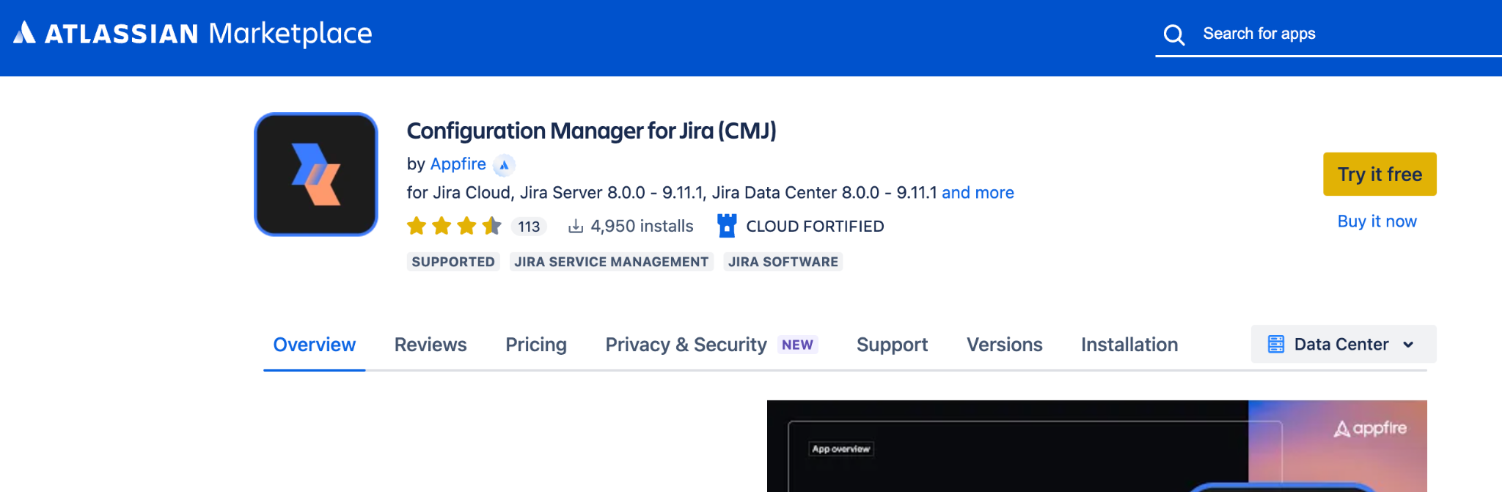

* Download the version 6.13.5 (Apps are normally distributed as JAR or OBR files, which are the only types of files accepted by the Jira file upload mechanism)
  + [Download link](https://marketplace.atlassian.com/download/apps/1211611/version/601300500) for Server instance
  + [Download link](https://marketplace.atlassian.com/download/apps/1211611/version/601300501) for Data Centre instance
* Log into BOS Jira as **System Administrator.**
* Click the Admin dropdown and choose **Manage Apps.**

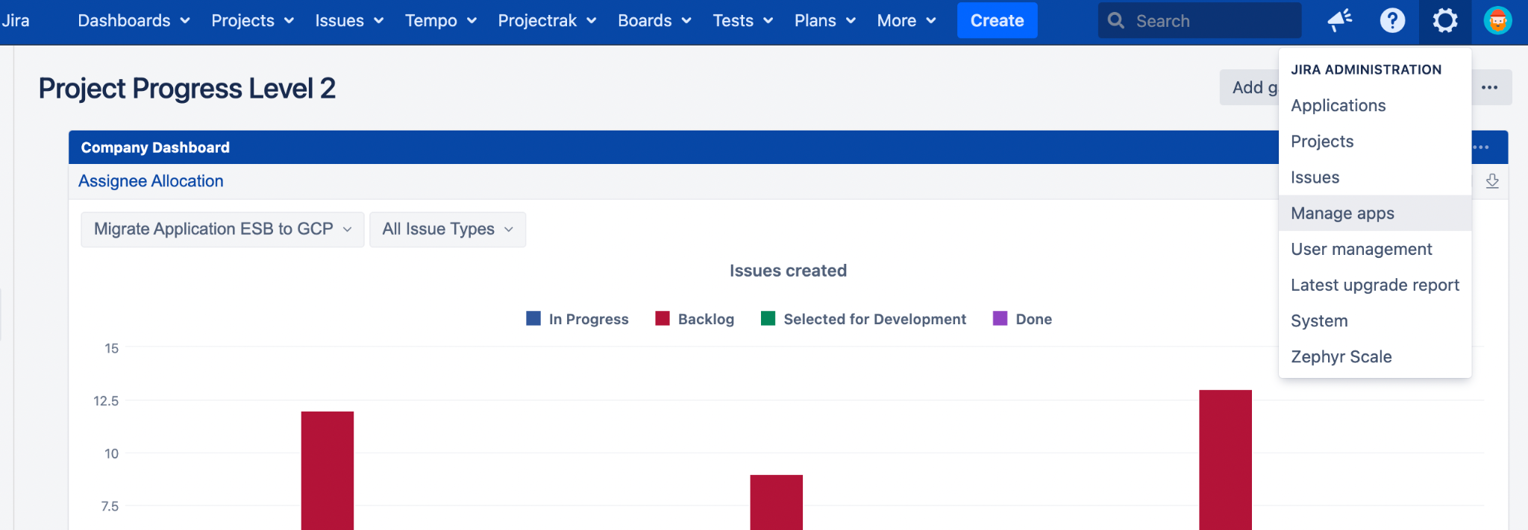

* On the left-hand panel, click **Manage apps.**

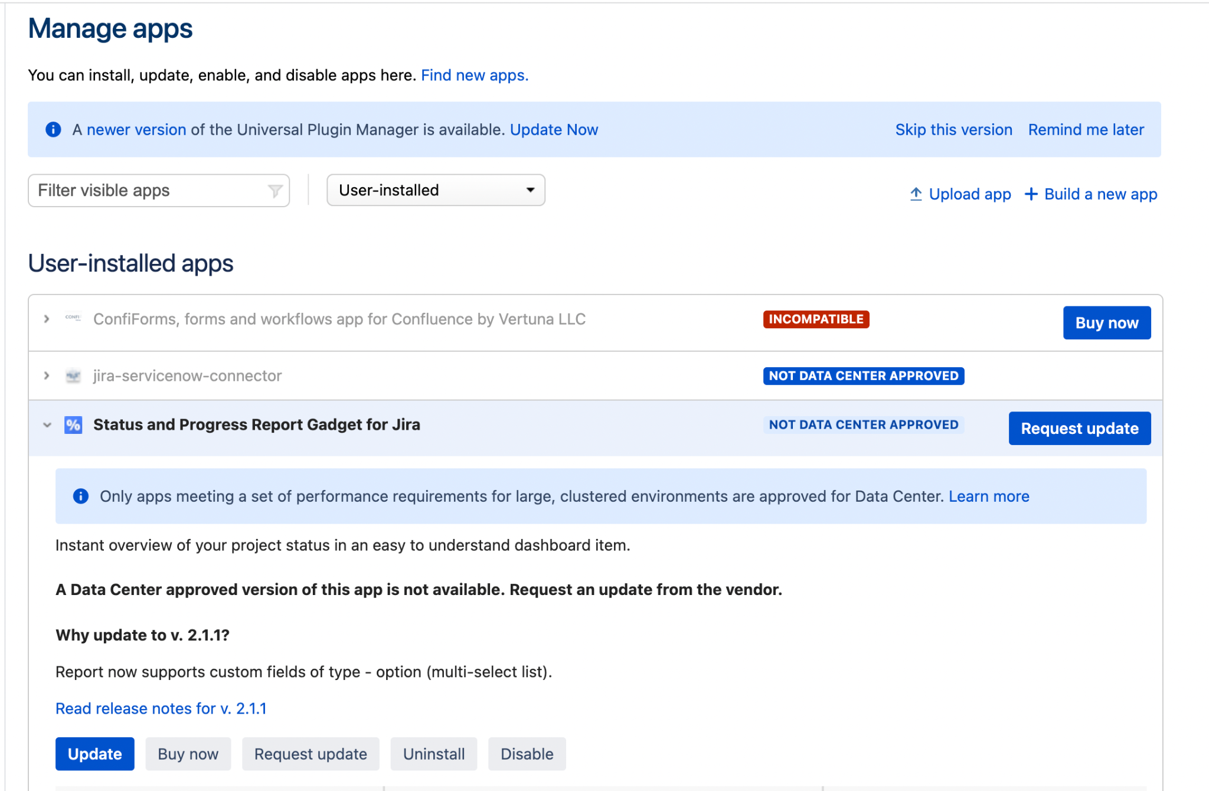

* From the top navigation bar, choose **Upload app**

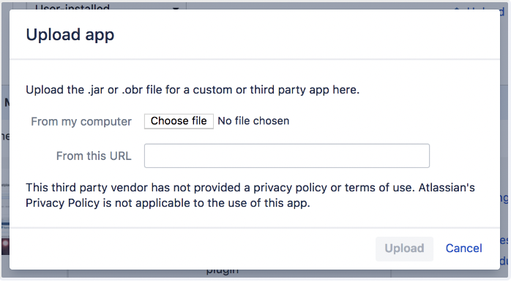

* Select the CMJ app file to upload
* Click **Upload**
* Once installation is complete, you may need to enter a license before you can use the app.
* Log into OCBC Jira as **System Administrator** and follow the same steps above to install the Configuration Manager add-on in the OCBC instance.

1. **Install Jira add-ons used by BOS instance in OCBC instance**

Assess the Jira add-ons enabled in BOS instance and in OCBC instance, including the add-on version and license status. The below list are the Jira add-ons that will be migrated. Other add-ons not mentioned below will not be migrated to the target instance because the target instance does not have corresponding add-ons.

|  |  |  |
| --- | --- | --- |
| Add-ons | Target Description | Version Consideration |
| Adaptavist ScriptRunner for Jira | Version: 7.12.0 | Utilize version 7.12.0 that already exist in the OCBC instance |
| Easy Agile User Story Maps for Jira | Version: 9.2.0 | Version that is compatible with OCBC JSW 9.6 version and current BOS version |
| JBehave for Jira | Version: 5.2.0 | Version that is compatible with OCBC JSW 9.6 version and current BOS version |
| Multiple Filters Chart Gadget | Version: 5.15.0 | Install same version with current BOS version as it is compatible with JSW 9.6 |
| Time In Status | Version: 4.30.0.750 | Utilize Version 4.30.0.750 that already exist in OCBC instance |
| UpRaise for Employee Success | Version: 9.1.0 | Version that is compatible with OCBC JSW 9.6 version |
| Zephyr Squad | Version: 9.2.2.92209740 | Utilize version 9.2.2.92209740 that already exist in the OCBC instance |

1. **Resolve conflict for configuration based on test result**

Based on the test result, several things need to be reconfigured before proceeding to import the BOS export file to the OCBC instance. Those things are as following:

1. Rename Custom Field (in BOS instance) that has the same name on OCBC production instance

* Log into BOS Jira as **System Administrator.**
* From the Admin console, navigate to the **Issues** page
* On the left hand panel, click **Custom Fields** under **Fields.**

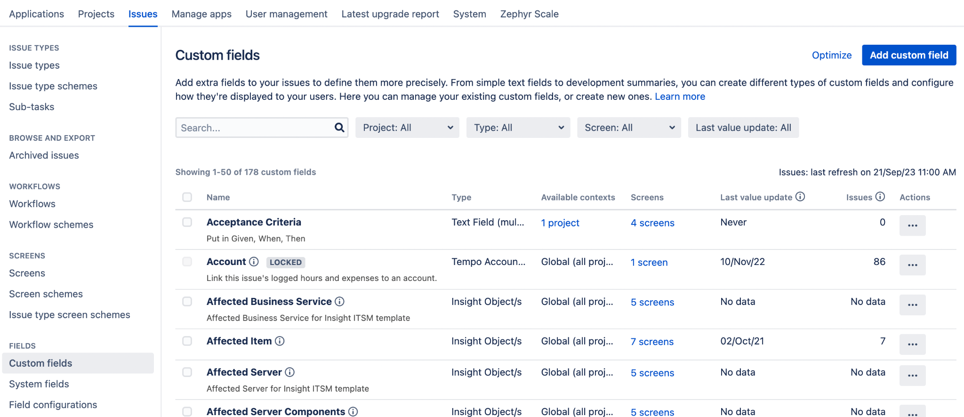

* Find the Custom Field you want to edit and select **the three dots under Actions,** then click **Edit.**

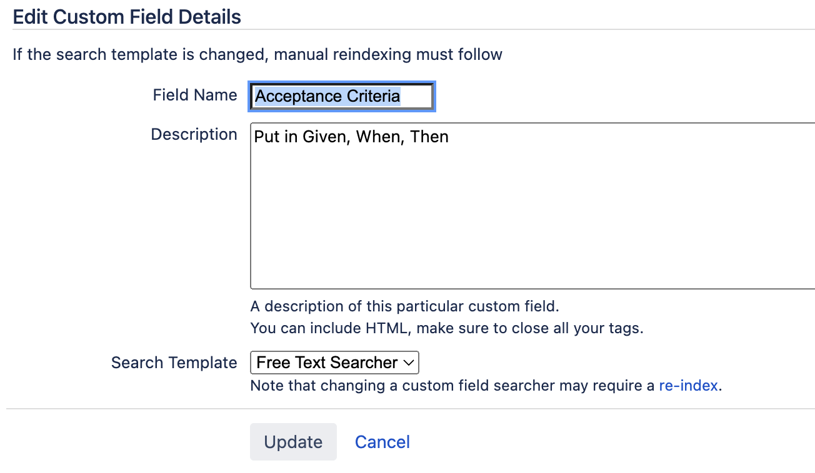

* Modify the **Field name** then click Update.

1. Rename Workflow Scheme in BOS instance, if there’s any scheme with the same name on the OCBC Production Instance

* Log into BOS Jira as **System Administrator.**
* From the Admin console, navigate to the **Issues** page
* On the left hand panel, click **Workflow schemes** under **Workflows.**
* Find the Workflow scheme you want to edit and select it.

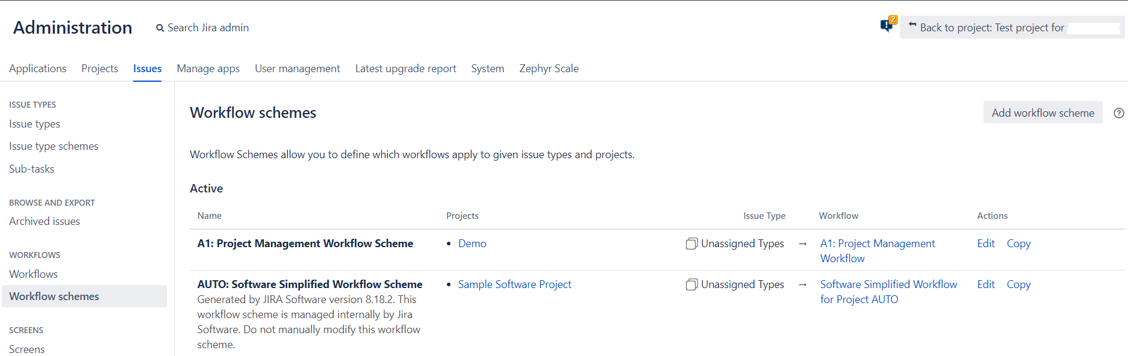

* Click **Edit** and modify the relevant fields.

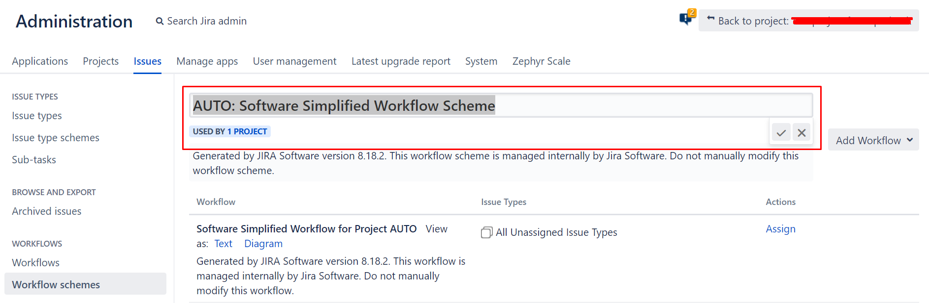

1. Rename Screen Scheme in BOS instance, if there’s any scheme with the same name on the OCBC Production Instance

* Log into BOS Jira as **System Administrator.**
* From the Admin console, navigate to the **Issues** page
* On the left hand panel, click **Screen schemes** under **Screens.**
* Find the Screen scheme you want to edit and select it.

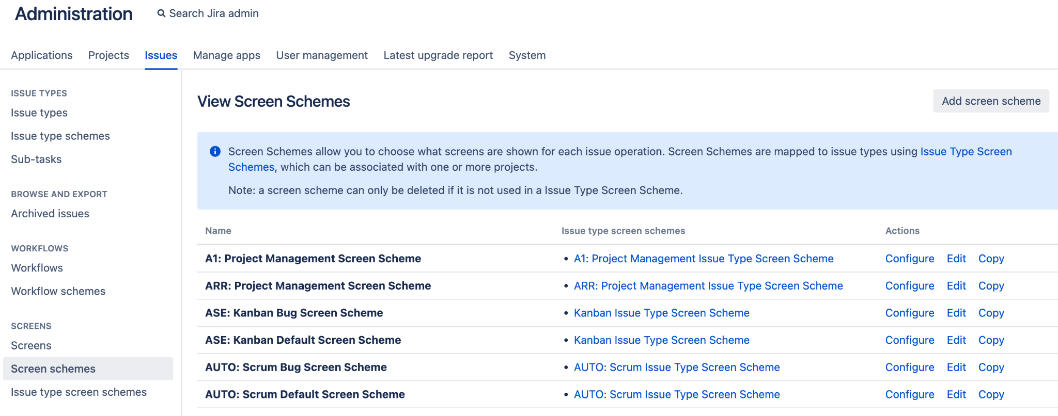

* Click **Edit** and modify the relevant fields.

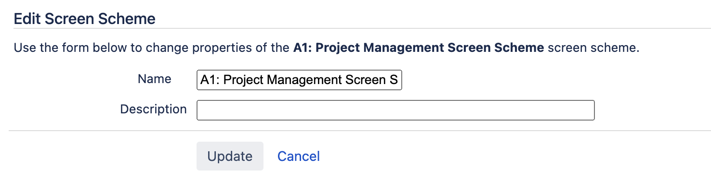

1. Rename Issue Type Scheme in BOS instance, if there is any scheme with the same name on the OCBC Production Instance.

* Log into BOS Jira as **System Administrator.**
* From the Admin console, navigate to the **Issues** page
* On the left hand panel, click **Issue type schemes** under **Issue Types.**
* Find the Issue type scheme you want to edit and select it.

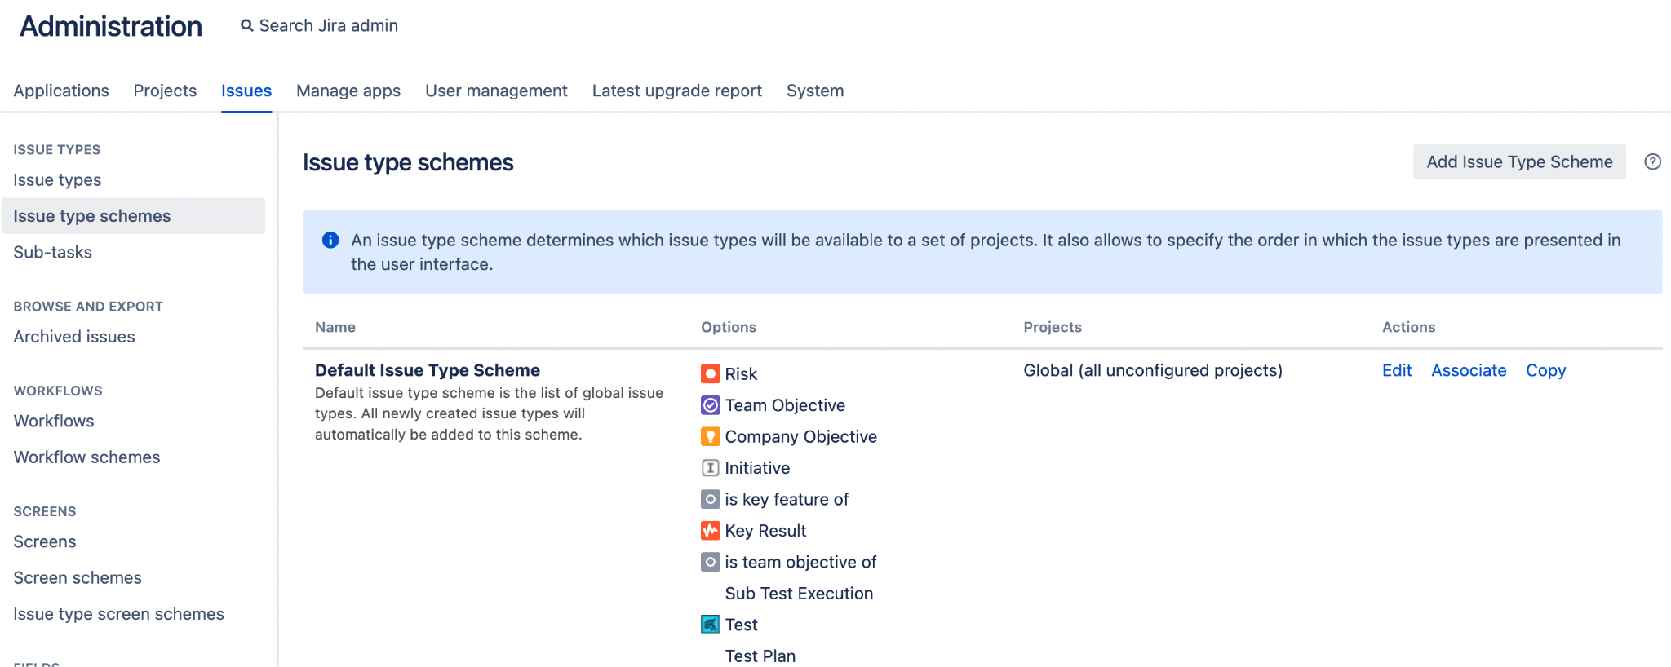

* Click **Edit** and modify the relevant fields.

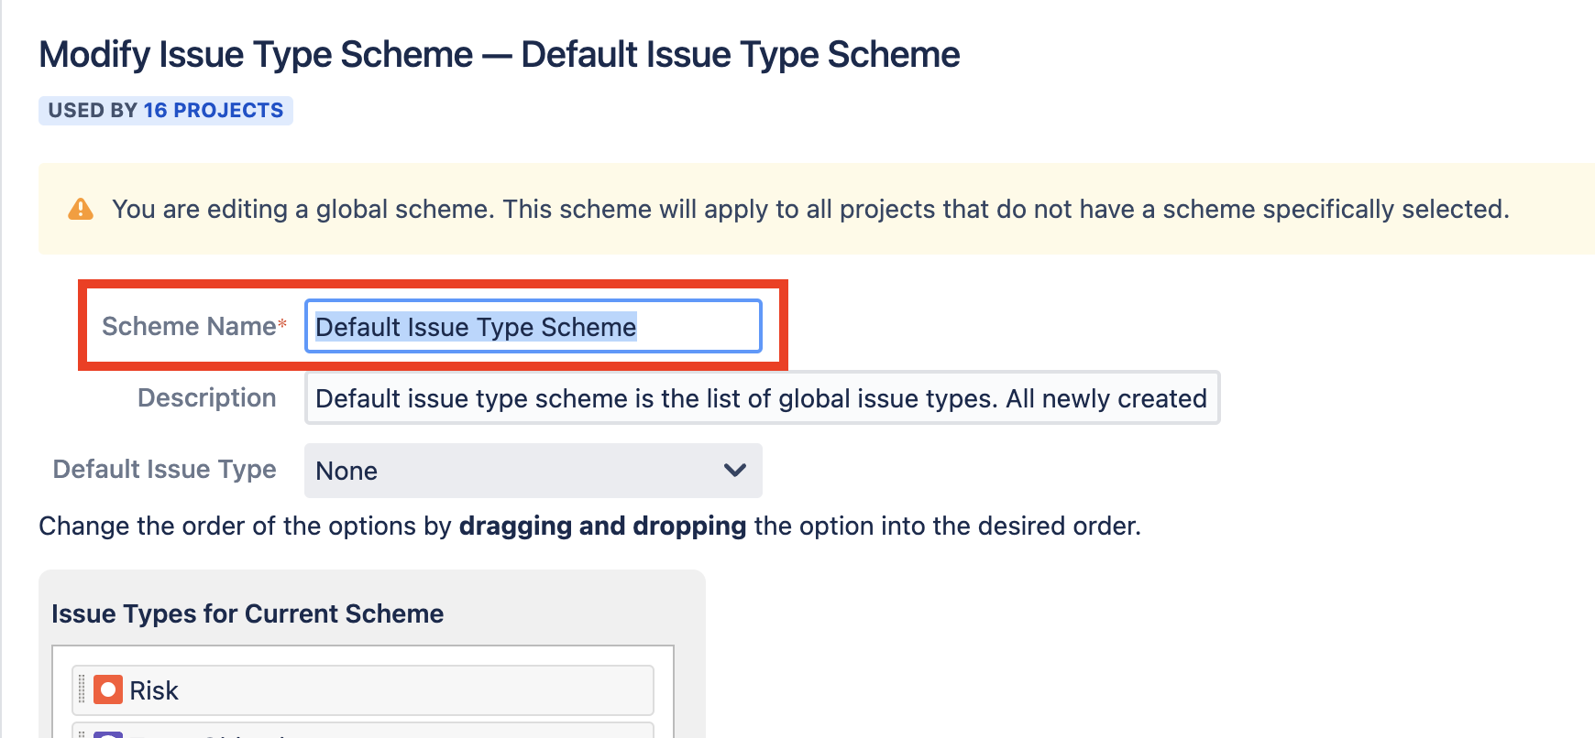

1. Rename Priority Scheme in BOS instance, if there is any scheme with the same name on the OCBC Production Instance.

* Log into BOS Jira as **System Administrator.**
* From the Admin console, navigate to the **Issues** page
* On the left hand panel, click **Priority schemes** under **Priorities.**
* Find the Priority scheme you want to edit and select it.

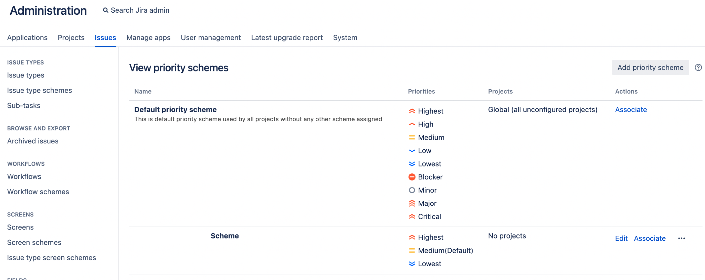

* Click **Edit** and modify the relevant fields.

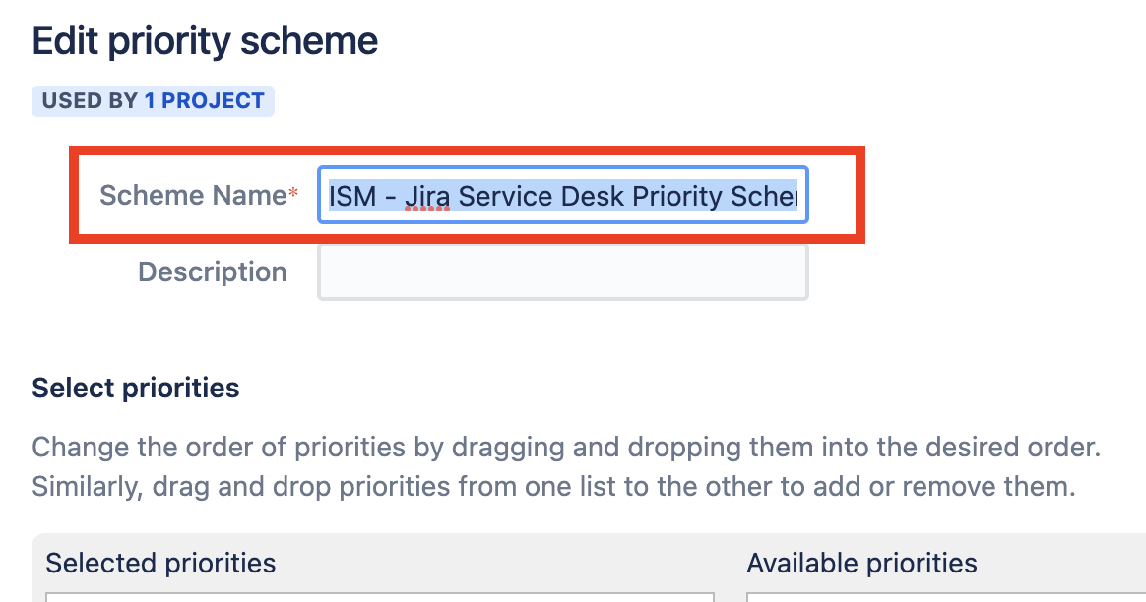

### 5.2.2 Migration Procedure

1. Take backup of data for OCBC instance

Before starting the migration process, OCBC will need to take database backup and file system backup.

1. Turn off OCBC Jira Service
2. Backup OCBC Database Data
3. Create the OCBC File System Backup
4. Turn on the OCBC Jira Service
5. Backup Jira xml

2. Capture Database statistics for BOS instance and OCBC instance.

You will need to

* Log into BOS Jira as **System Administrator.**
* From the Admin console, click on **System.**
* On the left-hand panel, click **System Info.**

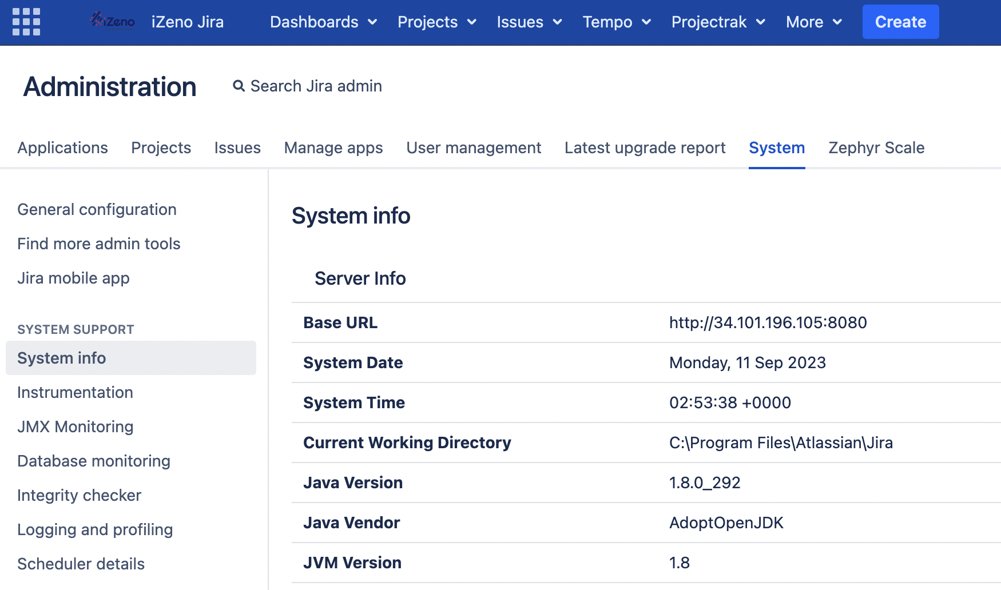

* Locate the **Database Statistics** section and take down the data count before migration, including:
  + Total count of Projects
  + Total count of Issues
  + Total count of Attachments
  + Total count of Custom Fields
  + Total count of Workflows
* Log into OCBC Jira as **System Administrator** and follow the same steps above to capture the Database Statistics for OCBC Jira instance before the migration.

3. Export BOS Jira project data using Configuration Manager

You will need to

* Log into BOS Jira as **System Administrator.**
* From the Admin console, navigate to the **Configuration Manager** page.
* On the left hand panel, click **Snapshots.**
* On the **Snapshots** page, select **Create Snapshot** on top right.

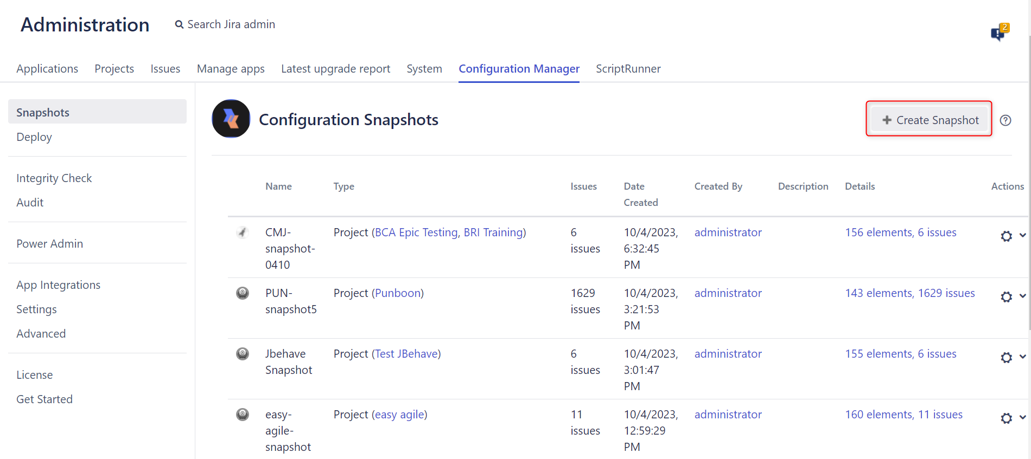

* On the page, click on **Projects with Issues** at the top and enter a name for the snapshot.

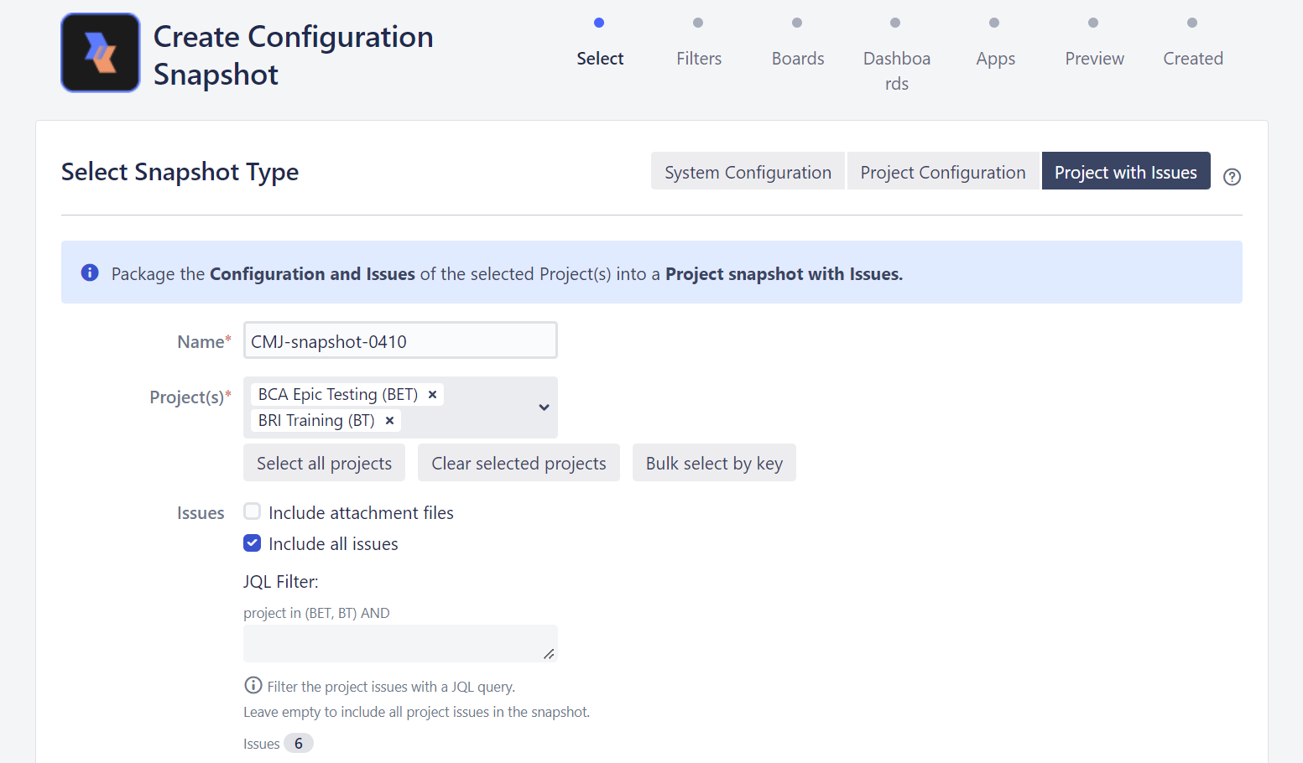

* To add all projects from Jira instance to a snapshot, click on **Select all projects** button. To select projects by their keys, first type the project keys in the field and then click on **Bulk select by key** button.
* Select **Include all issues** checkbox.
* Click the checkbox at the bottom of the page to add filters, Agile boards and Dashboards in the snapshot if you want to.
* Click the **Create** button and wait while the snapshot is being created. A message will be displayed, confirming that the Configuration Manager has successfully created the snapshot.

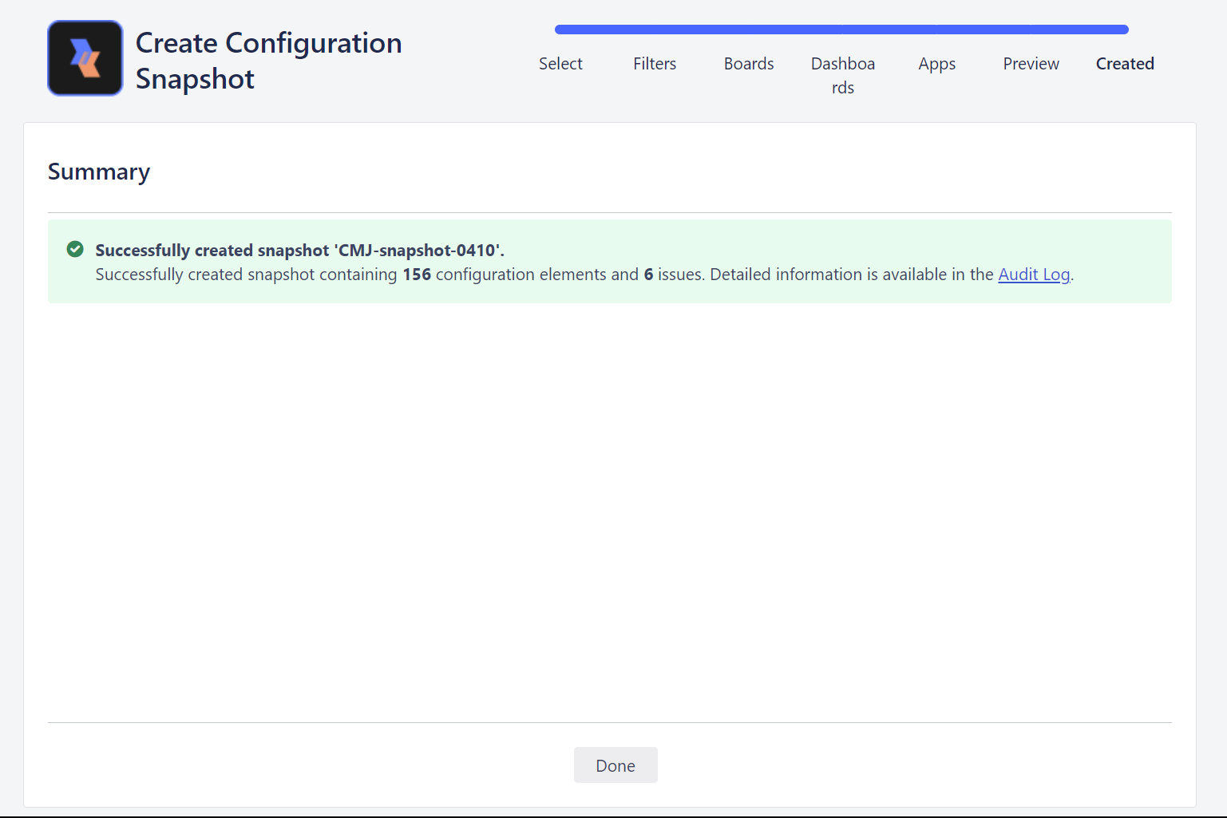

* Click done and on the **Snapshots home page**, next to the snapshot you created, click the action button to **download** it.

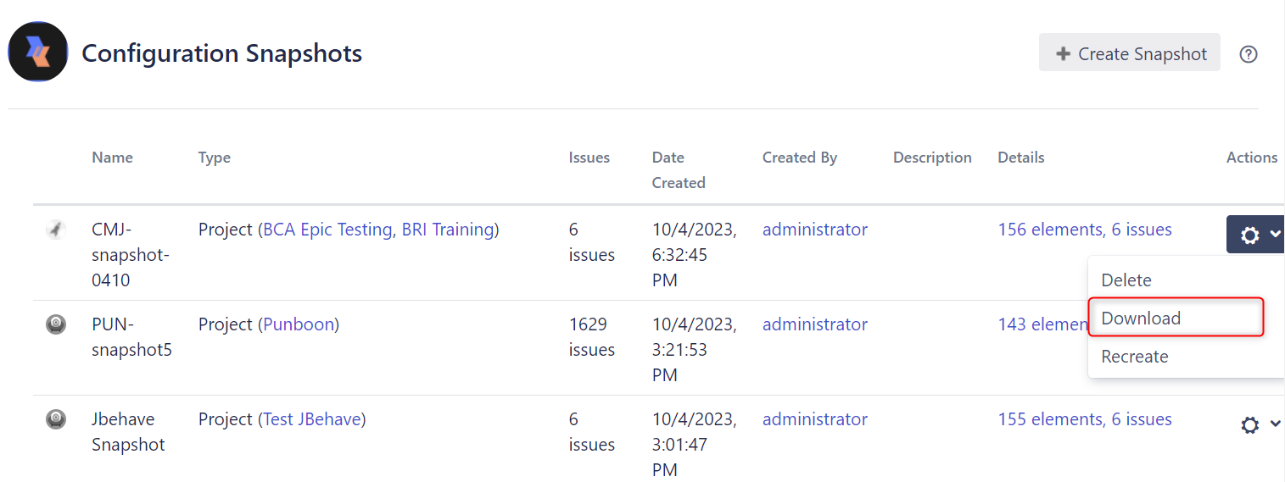

4. Copy attachment data to OCBC instance

To transfer all the attachments data from BOS Jira instance to OCBC Jira instance, you can transfer using SCP method.

5. Import to OCBC Jira instance using Configuration Manager

You will need to

* Log into OCBC Jira as **System Administrator.**
* From the Admin console, navigate to the **Configuration Manager** page.
* On the left hand panel, click **Deploy.**
* On the **Deploy** page, select **From Snapshot File** on top right.

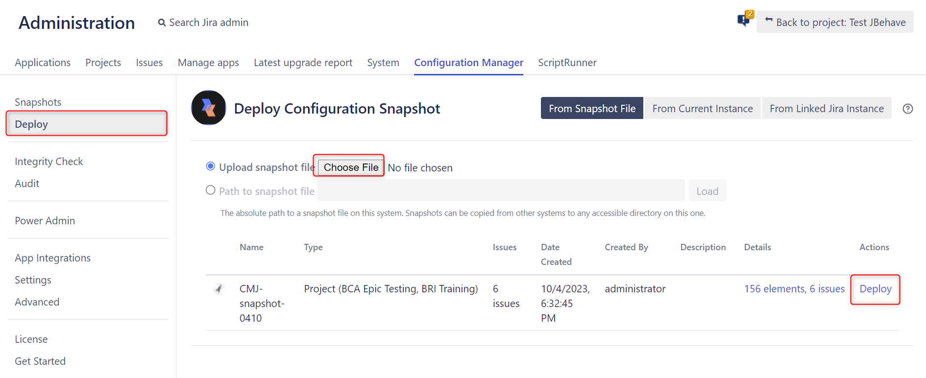

* Choose either the **Upload snapshot file** or **Path to snapshot file** option. The Path to snapshot file option allows you to enter a location to a snapshot file on the current Jira instance you are performing the deployment in.
* After the file is loaded, you will see the snapshot file listed on the page.
* Click on the **Deploy button** for this snapshot to start the deployment process.
* On the **Select** page, you can use Advanced Options to select elements you want to skip during the deployment.

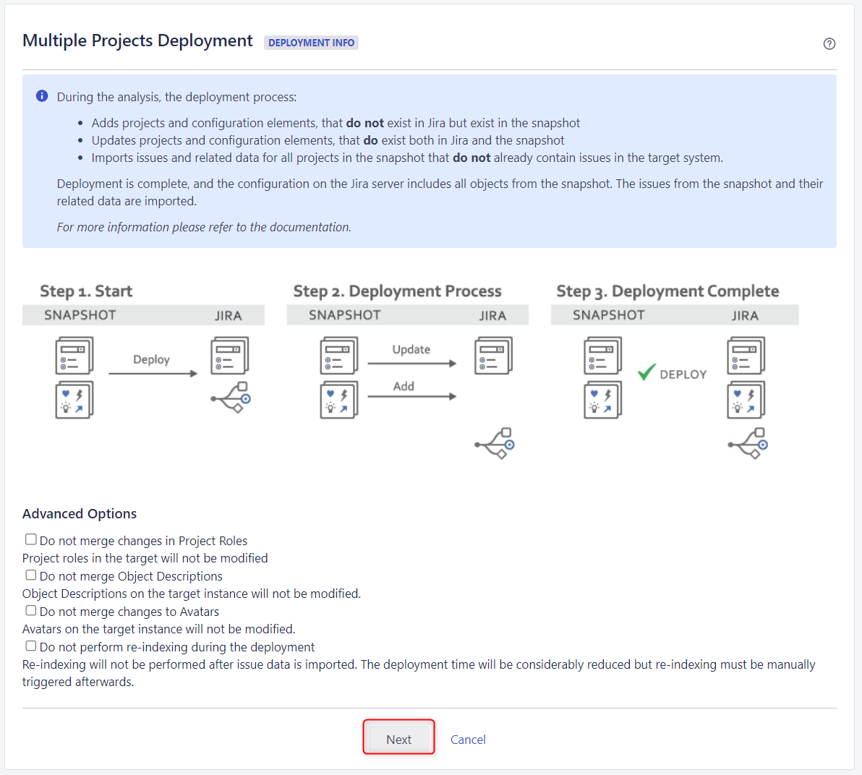

* Click the **Next** button.
* On the **Analyze Configuration Changes** page, you can review all the changes from the deployed snapshot that will be applied on the target Jira instance, and how those changes will impact the existing projects.

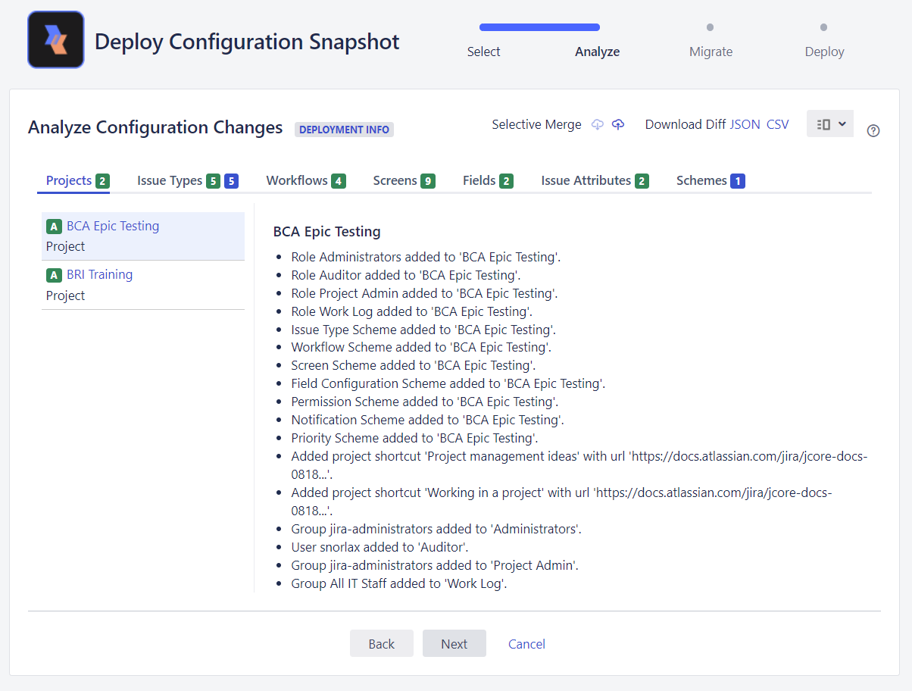

* Check each of the configuration change and decide whether to merge to existing object or create new element. Click the **Next** button.
* On the **Analyze import data** page, you can review the issue data-related changes for each project that will be migrated. Click the **Next** button.

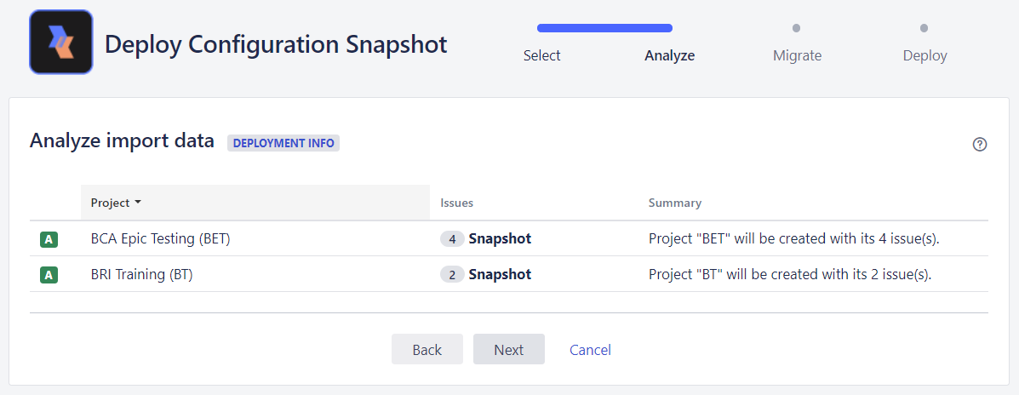

* Click next and start the deployment.
* Wait for the deployment process to finish.

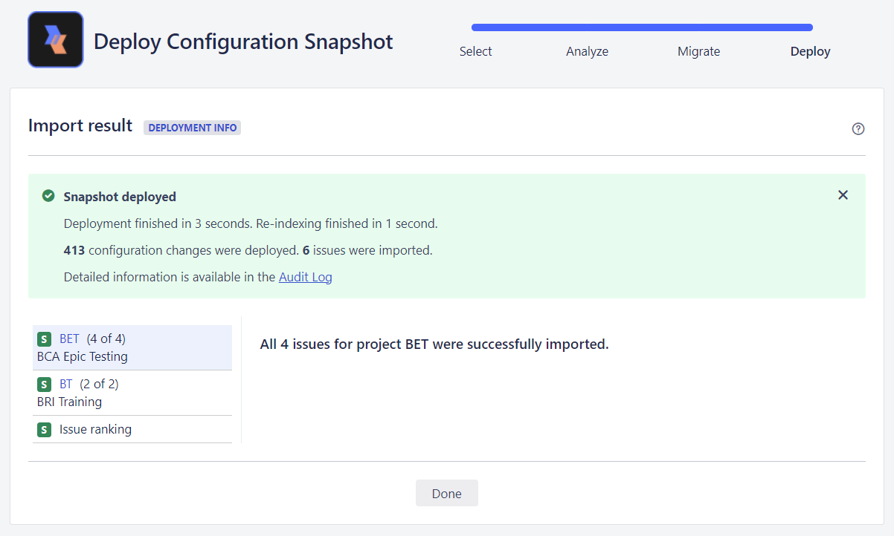

### 5.2.3 Post-Migration Procedure

1. Re-Index OCBC Instance

You will need to

* Log into OCBC Jira as System Administrator.
* From the Admin console, click on **System.**
* On the left-hand panel, click **Indexing** under **Advanced** section.

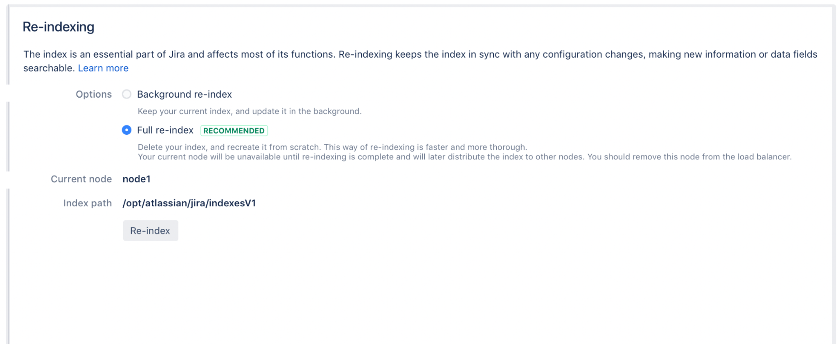

* Choose the option of **Full re-index**.
* Current node is where the re-index will be performed.
* Index path is the directory where the index is stored. To change the index path, you must be logged in as System Administrator with global permission.
* After the re-indexing is complete, let the Jira User do Business as usual in the OCBC Instance.

1. **Validate the delta statistical count of the BOS Jira data migrated**

You will need to

* Log into OCBC Jira as **System Administrator.**
* From the Admin console, click on **System.**
* On the left-hand panel, click **System Info.**



* Locate the **Database Statistics** section and compare the data count before and after the import.
  + Total count of Projects
  + Total count of Issues
  + Total count of Attachments
  + Total count of Custom Fields
  + Total count of Workflows

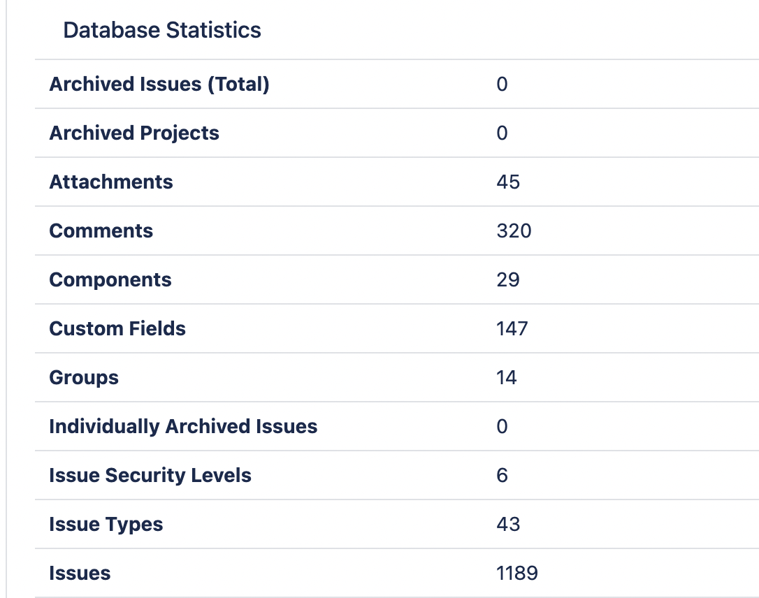

1. **Validate the functions of Jira**
2. Health Check

Check the health status of Jira instance

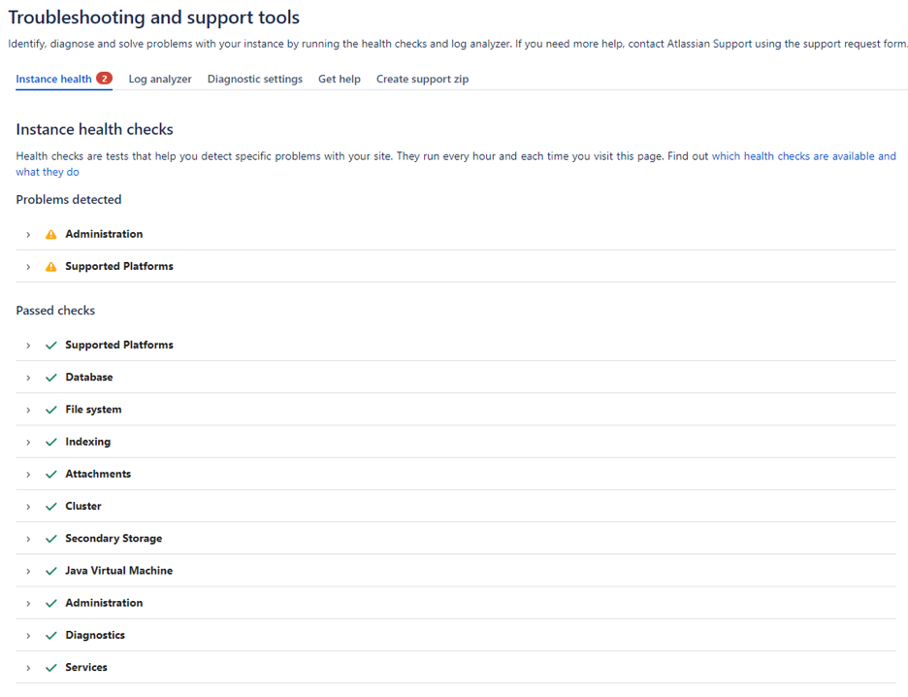

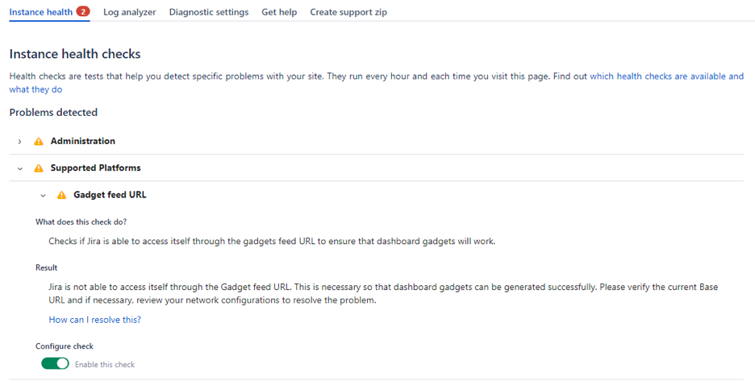

1. Create an issue

Test basic issue functionality.

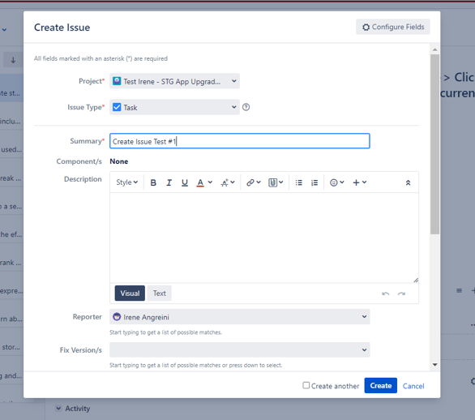

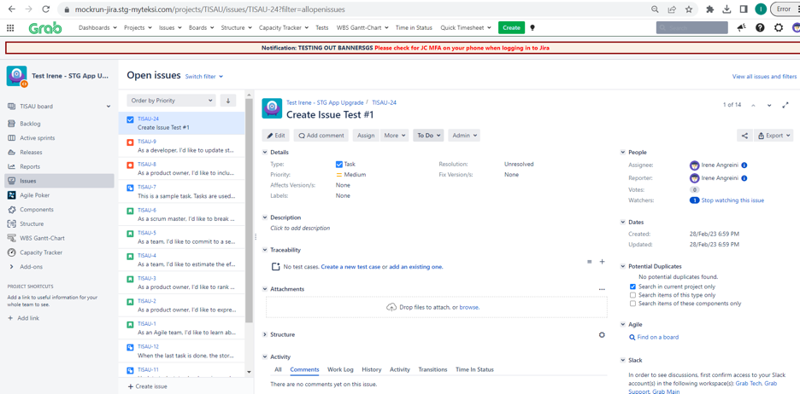

1. Edit an issue

Test basic issue functionality.

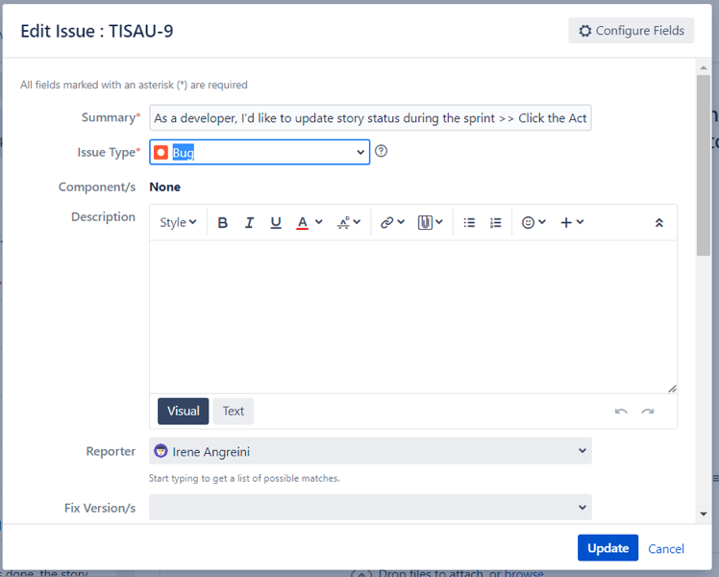

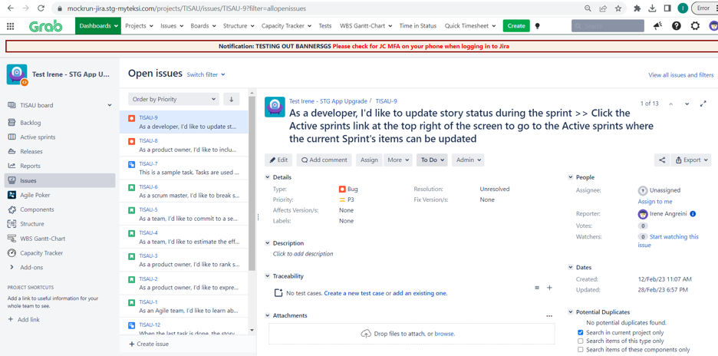

1. Delete an issue

Test basic issue functionality.

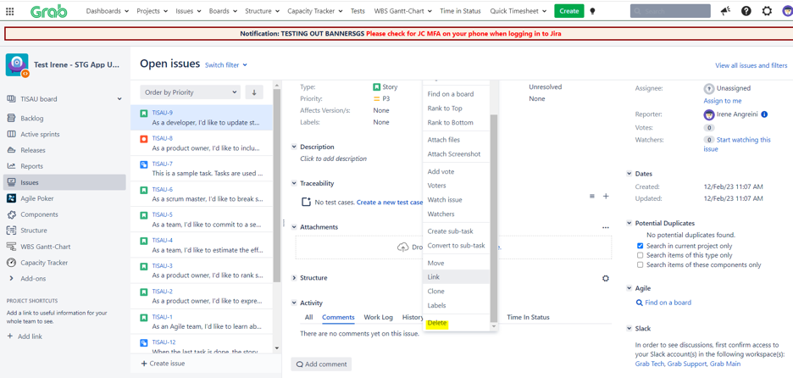

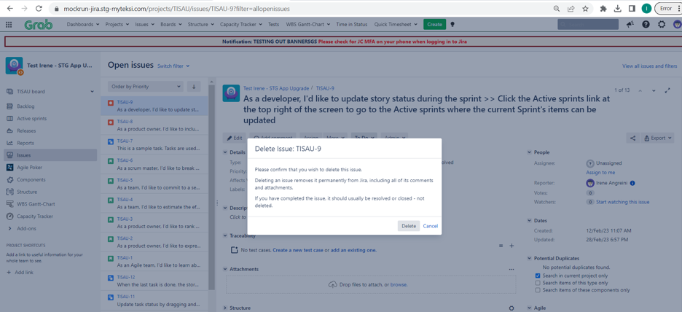

1. Layout Manager

Check the display whether working as expected

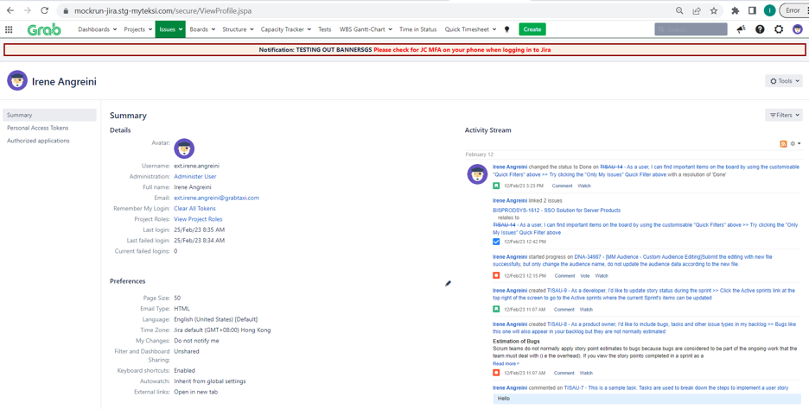

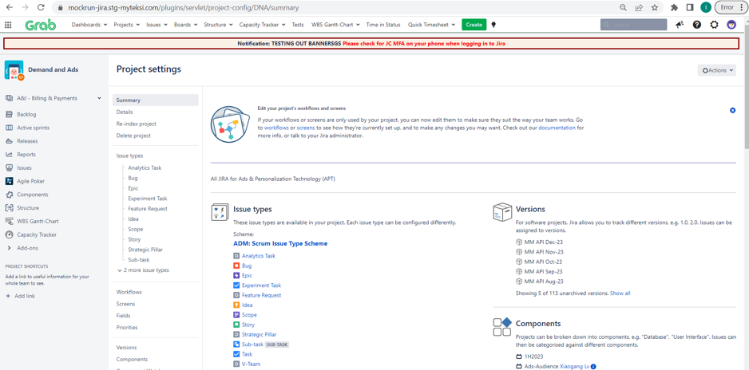

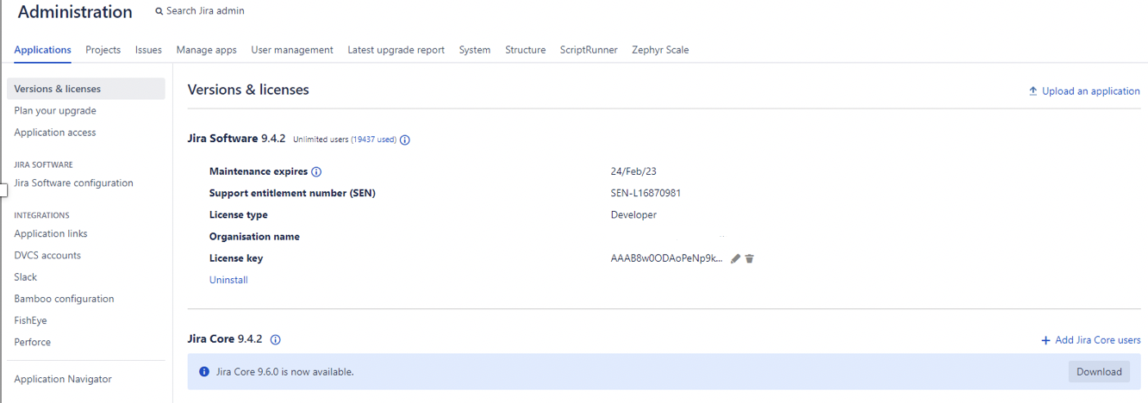

1. Permissions

Test the user actions is aligned with permission configuration

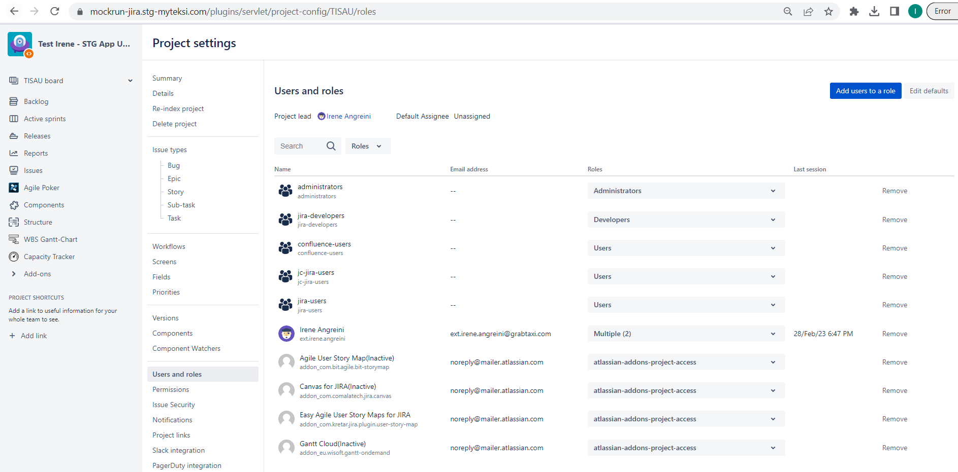

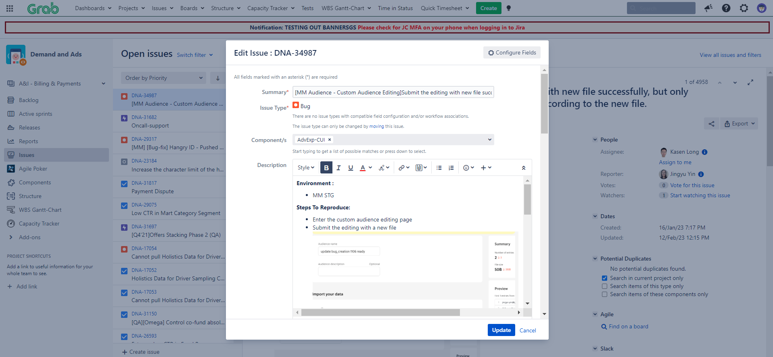

(g) Search functionality

Test whether the search functionality is working.

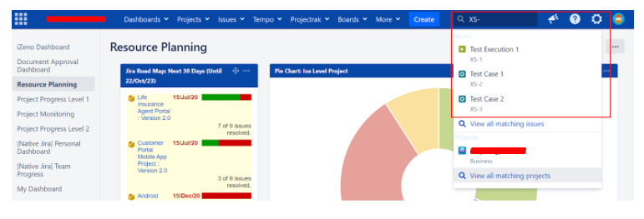

(h) Dashboard

Check that the native dashboard and dashboard with add on gadget are displayed as expected. 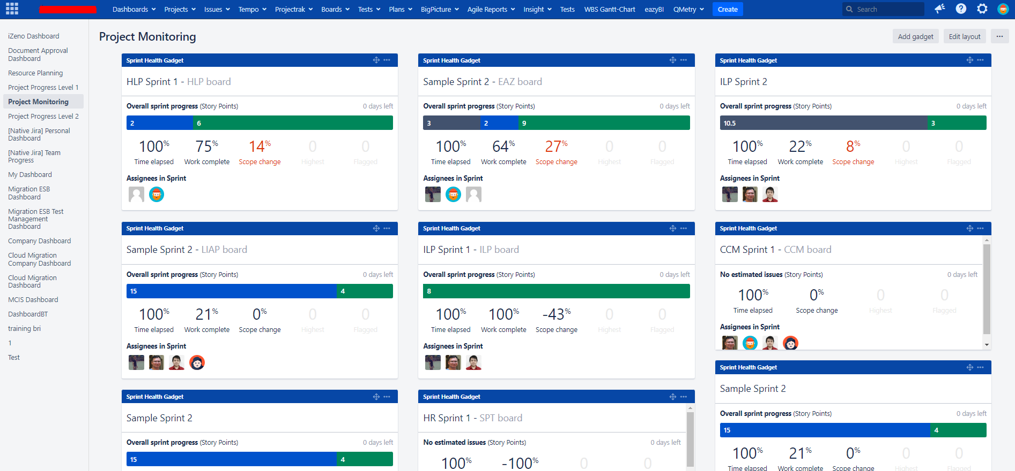

1. **Validate the function of Jira add-ons**

You will need to

* Log into OCBC Jira as **System Administrator.**
* Test the functionality of each of the Jira add-ons as below.

1. Adaptavist ScriptRunner for Jira

* Select **ScriptRunner** from the Administration console.

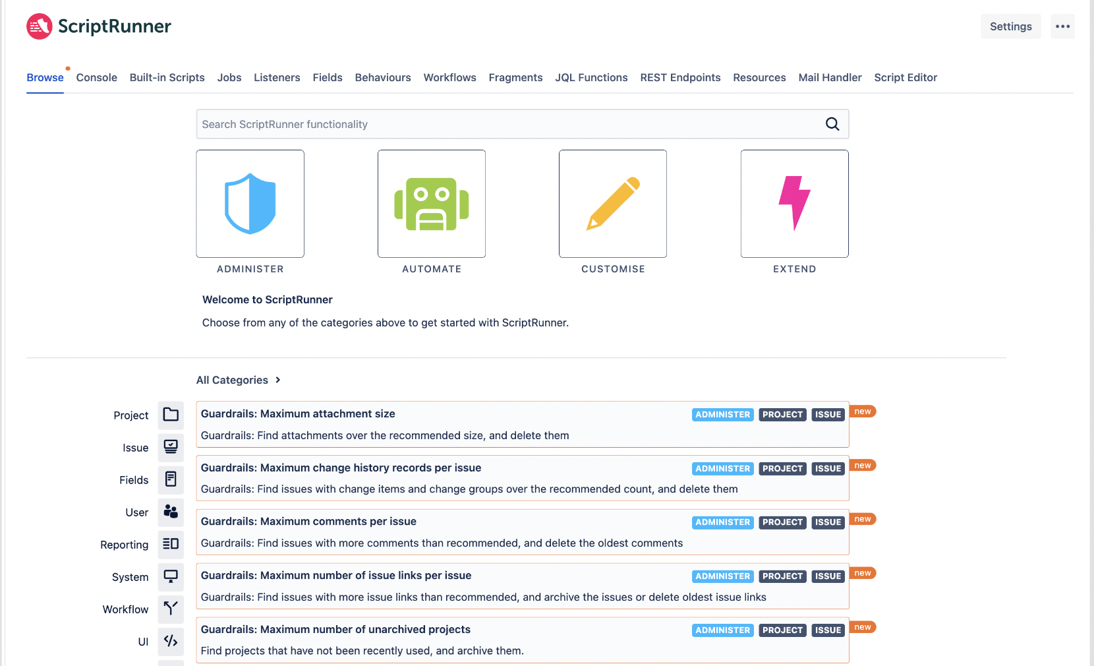

* Use the **search** bar to search for scripts by name or goal. You can select **categories** and **filters** to further narrow down the search results
* Inthe **Console** tab, you can copy/paste or upload your script to test the script functionality.

1. Multiple Filter Charts Gadget

* Select the dashboard you wish to add the gadget in



* Click on **Add gadget.**
* Search for **Multiple Filters** and add the desired gadget

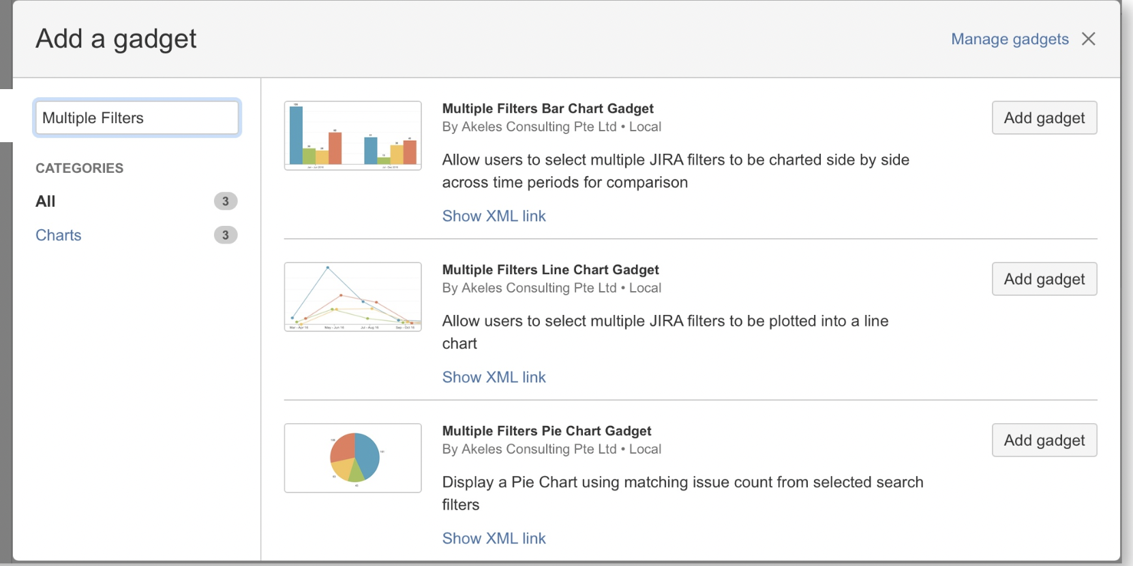

* Configure the gadget by selecting the options on the next screen and view the displayed output.

1. Time In Status

* Select **Time In Status** from the top menu navigation.

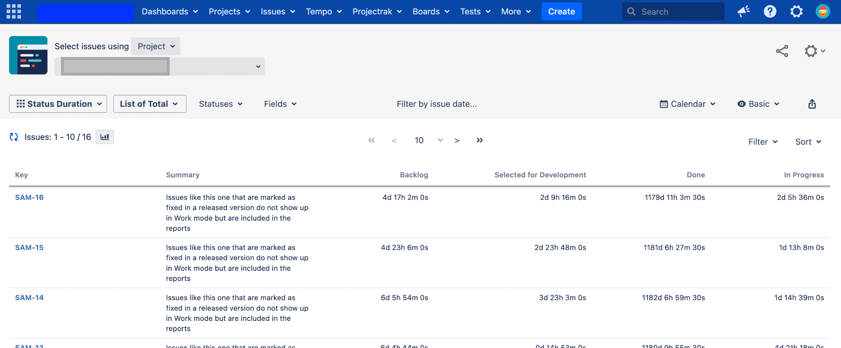

* You can change the below options to show a different report view
  + Filter Type
  + Columns By
  + Statuses
  + Fields
  + Date Range
  + Calendar

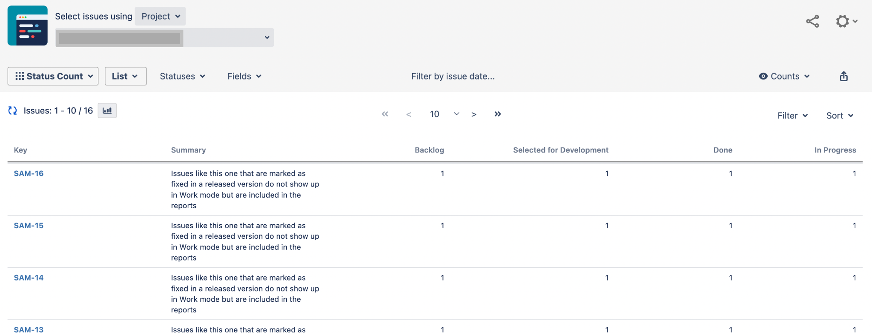

1. Easy Agile User Story Map

* Select one of the project and click on **User Story Map** from the project menu sidebar.

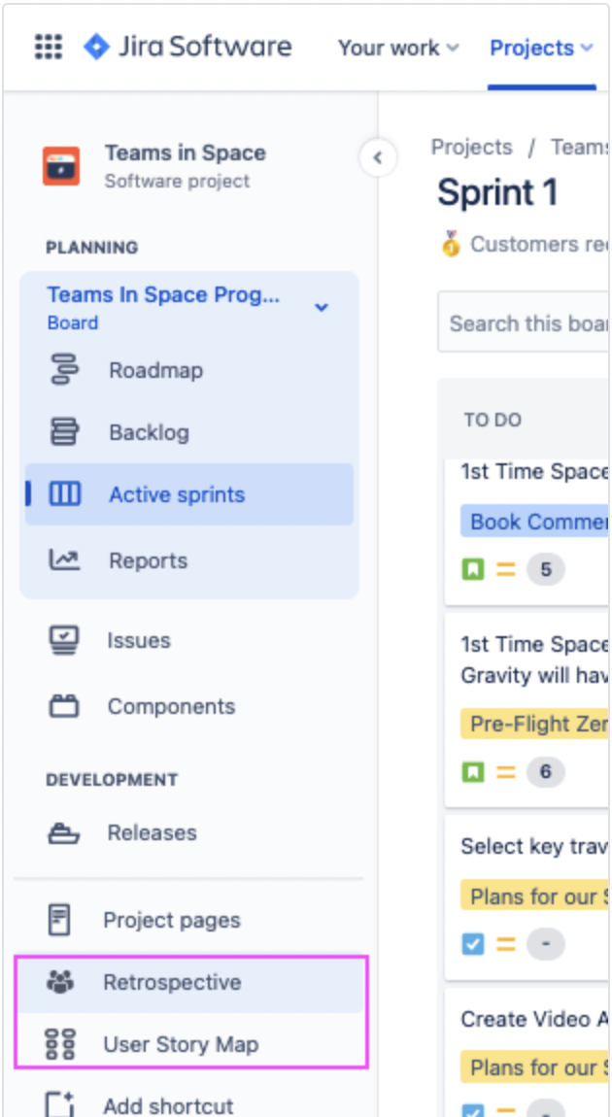

* The screen will show the Epics lining the top of the Story Map, with their linked issues below in the respective Sprint swimlane.

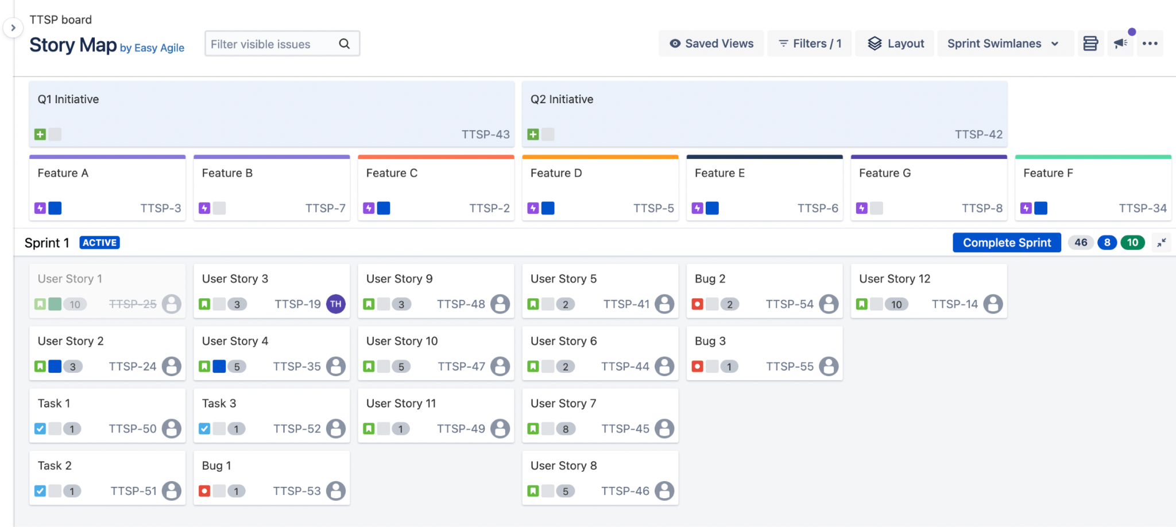

1. JBehave for Jira

* Select the project you wish to have JBehave add-on enabled for.
* Under the project’s administration page, navigate to the JBehave configuration page and enable it.
* Once enabled, navigate to one of the issue in this project and click on **Add User Story** to start adding JBehave stories.

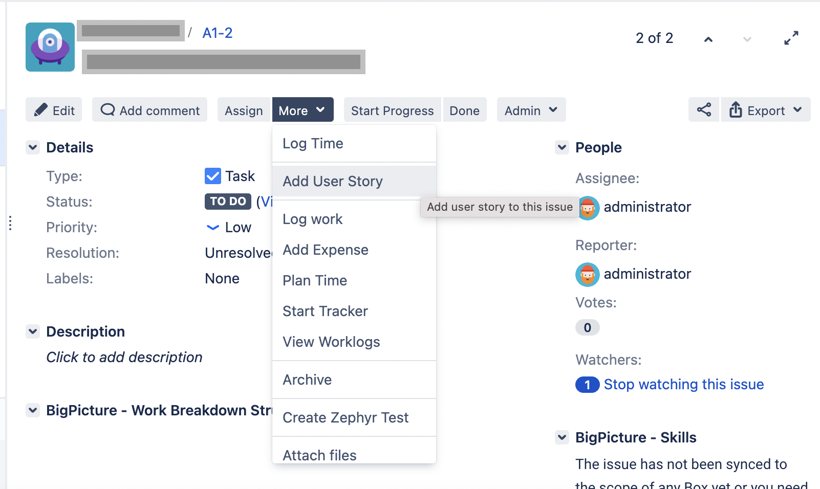

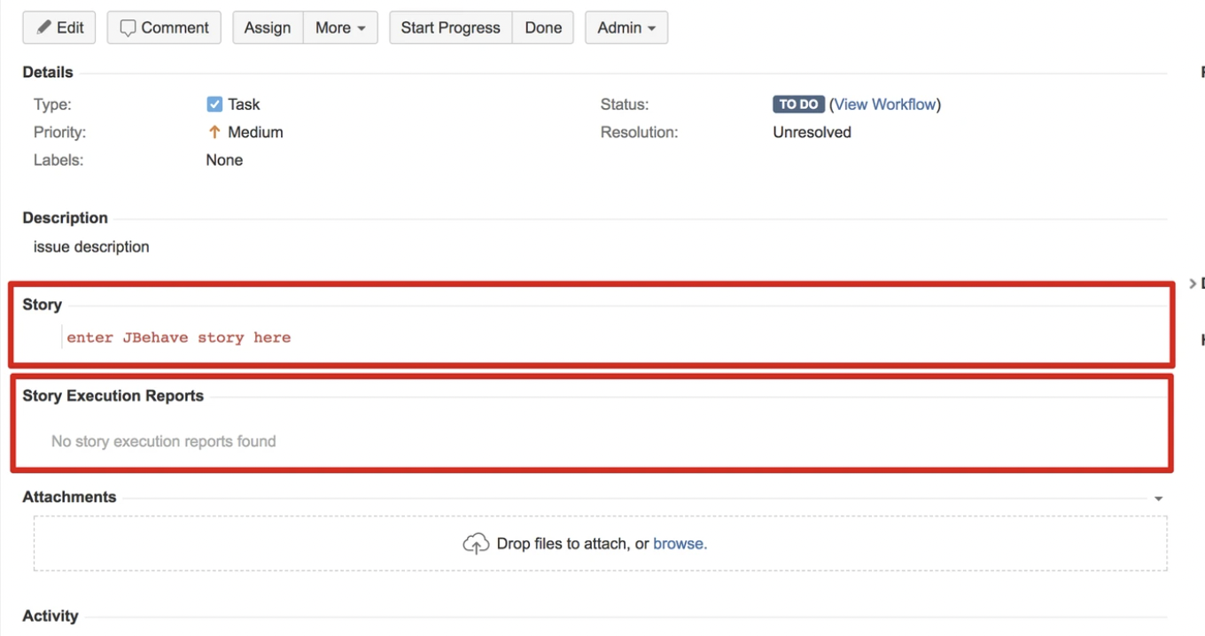

1. Upraise for Employee Success

* Select **Upraise > Dashboard** from the top menu navigation.
* You can view or edit existing dashboards; or click on **Create dashboard** to create your own.

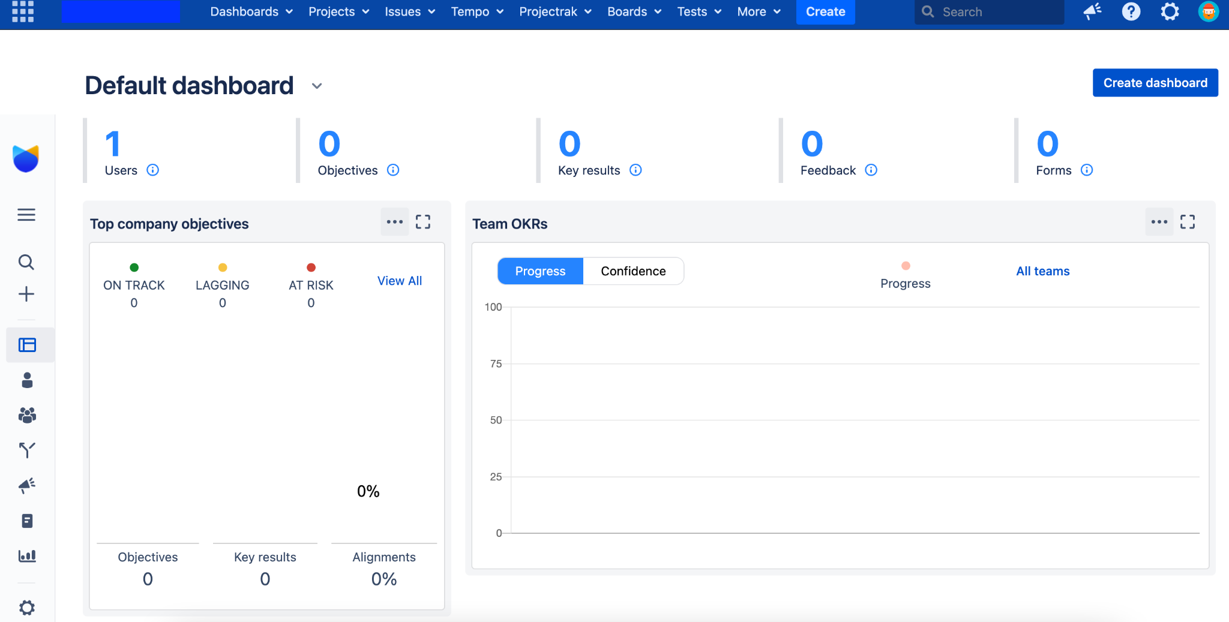

* In the **Forms** page, you can view the forms you are involved in, as well as create form template for use.

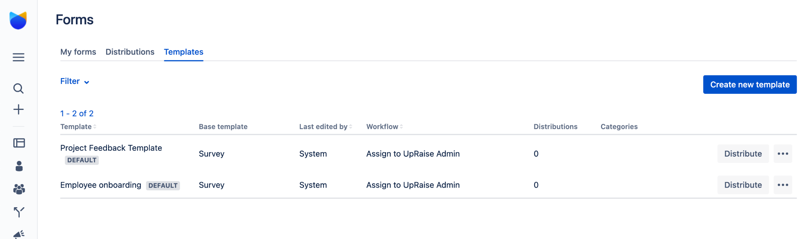

1. Zephyr for Jira

* Select **Tests > Test Summary** from the top menu navigation

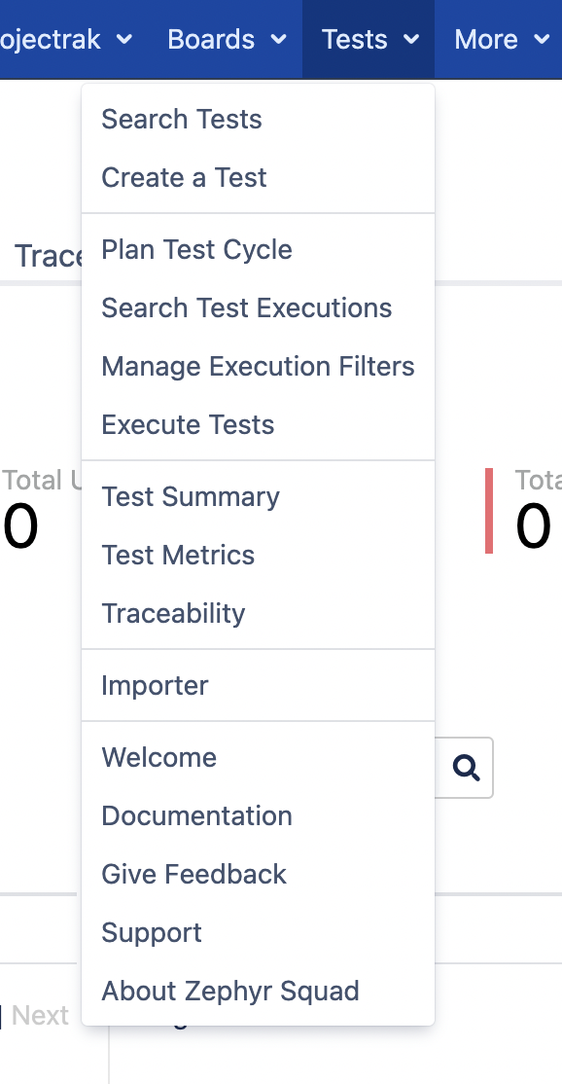

* The Test Summary will show the view of the all the tests that belong to a particular project

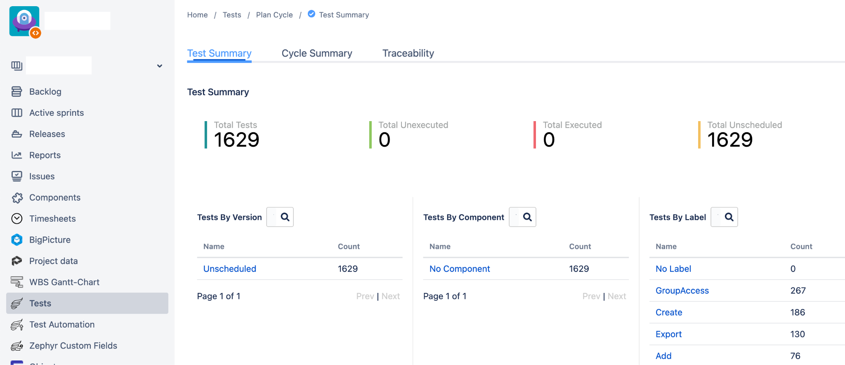

* Click on **Create a Test** to create a test for the project. A test can be created similarly to any issue type in Jira.

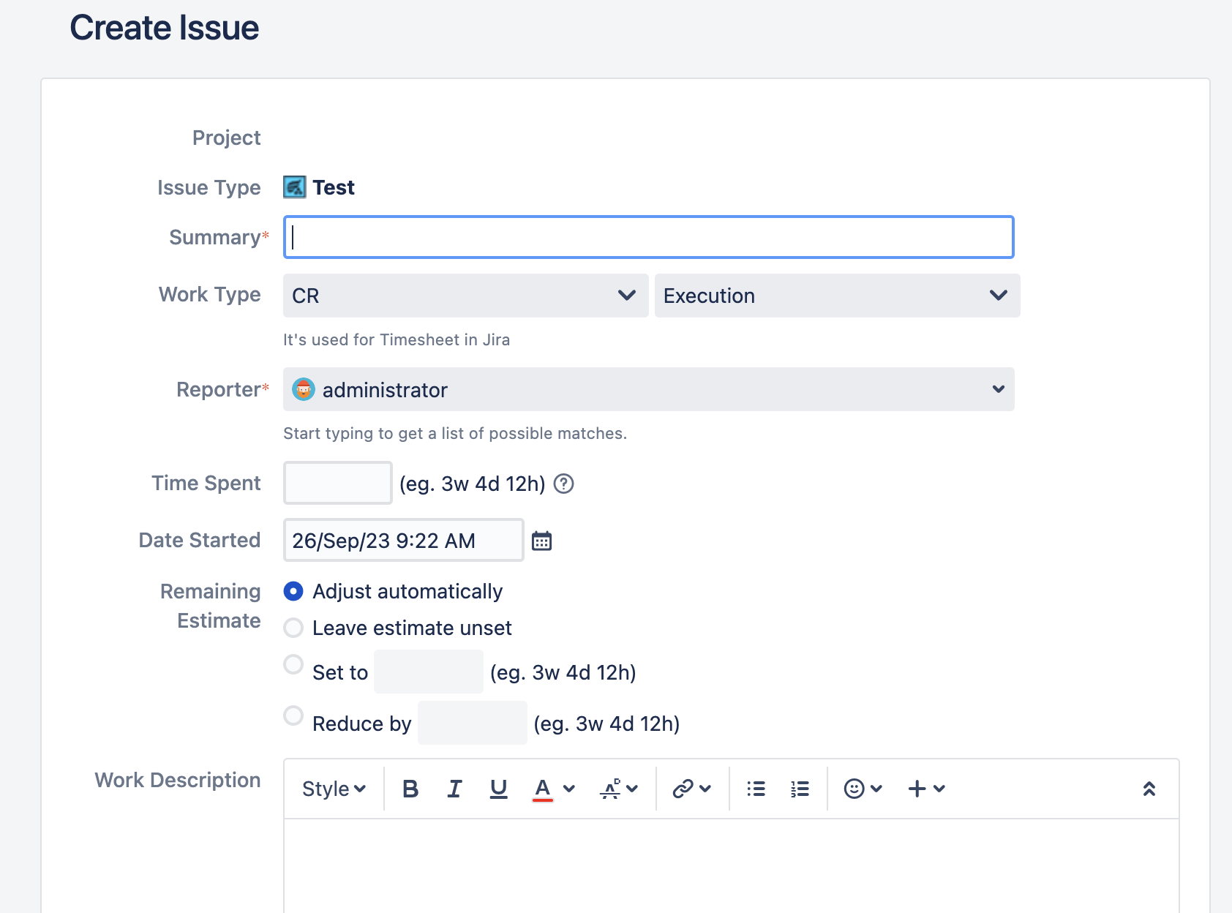

## 5.3 Add-On Data Migration

|  |  |  |
| --- | --- | --- |
| Add-ons | Description | Method of Migration |
| Adaptavist ScriptRunner for Jira | Can be Migrated Using Configuration Manager. Script functionality verification will be part of Post Migration Activity. But no package / class has been deprecated with the upgrade. | Configuration Manager |
| Easy Agile User Story Maps for Jira | Data has to be recreated manually. | Recreate - Manual |
| JBehave for Jira | Data has to be recreated manually. | Recreate-Manual |
| Multiple Filters Chart Gadget | Migrated using Configuration Manager | Configuration Manager |
| Time In Status | Able to migrate because the data using jira issue history which Configuration Manager can migrate | Configuration Manager |
| UpRaise for Employee Success | There is no export import method, and the data can’t be migrated using Configuration Manager. Data will be recreated manually. | Recreate - Manual |
| Zephyr for Jira | Using Zephyr Squad native export and import, populate additional data (test execution) with script to migrate | Configuration Manager for the issues data  Zephyr importer for Test Execution and Test case  Script Migration for Test Folder, and Cycle Assignment |

### 

### 5.3.1 ScriptRunner Add-On Data Migration

Adaptavist ScriptRunner for Jira is a collection of powerful but easy-to-use workflow functions, JQL functions, listeners, and services, enabling the automation of a wide range of tasks in Jira and other tools in the Atlassian ecosystem. Configuration Manager currently supports ScriptRunner post functions, validators, and transitions. When these scripted items reference other configuration objects, Configuration Manager will be able to handle them appropriately during migration.

The prerequisite for Scriptrunner to be able to migrate with Configuration Manager is Configuration Manager version 6.13.5 or newer and ScriptRunner version 6.5.0 or newer with details [here](https://appfire.atlassian.net/wiki/spaces/AppIn/pages/467964237/List+of+all+Integrated+Apps). The instances are able to meet these prerequisites. With that prerequisite, the migration can cover ScriptRunner for Jira (post functions, validators, and transitions).

### 5.3.2 Zephyr Squad Add-On Data Migration

Zephyr Squad is a Jira Add-on that brings test management capabilities specifically built to cater the needs of QA/Tester team use cases. With the addition of Zephyr Squad, tests can be created and viewed in any Jira project, linked to other issues, executed immediately or as part of a test cycle and detailed test metrics can be tracked via customized gadgets.

The main data migrations using Configuration Manager are not able to cover Zephyr Squad Data Migration and especially data merge considering target instances already have Zephyr Squad data. To migrate and merge the data, a combination of Zephyr Specific Export and Import with some manual API Data migration will be used. To be more exact, test executions and test cases will be migrated using the export import method, while test folder and cycle assignment will be recreated manually using REST API. For OCBC UAT instance, the script will be run via Jenkins and for Production instance, the script will be run using a local laptop because it has access without citrix to production.

### 5.3.3 Time in Status Data Migration

Time in Status prepares the report using the Jira Issue History and using the Configuration Manager we can migrate the issue history. The process of the migration will be the same as the Configuration Manager data migration.

To check the data report succeed, we can go to the Time in Status and can check the duration the issue is in the status.

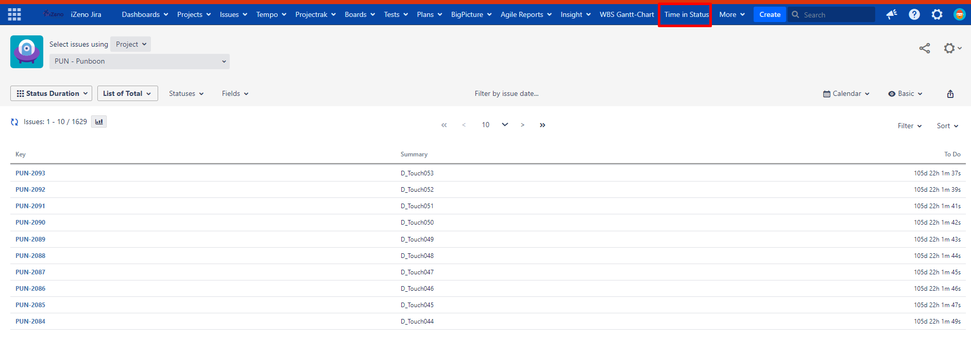

### 5.3.4 JBehave for Jira Data Migration

JBehave data cannot be migrated using Configuration Manager. It has to be recreated manually.

To recreate the data, we need to run the below SQL query:

|  |
| --- |
| SELECT * FROM "AO_EEBD71_JBEHAVE_STORY"; |

This data is the User Story Field. We then manually copy and paste this data to the targeted issue.

### 5.3.5 Multiple Filters Chart Gadget

Multiple Filters Chart Gadget can be migrated using Configuration Manager. The process to migrate is the same as when using the Configuration Manager. The migrated data are the Filters and Gadgets.

The respective dashboard needs to be shared to the project so it can be included when migrated.

To check if the data has been migrated, we need to run this query in the Jira database: This query will return all the dashboards that use Multiple Filters Chart Gadget.

|  |
| --- |
| SELECT pp.pagename, pc.gadget_xml, count(pc.gadget_xml)  FROM portalpage pp  JOIN portletconfiguration pc ON pp.id = pc.portalpage  WHERE pc.gadget_xml LIKE '%MultipleChartsGadget%'  GROUP BY pp.pagename, pc.gadget_xml; |

### 5.3.6 Easy Agile User Story Maps for Jira Data Migration

Cannot be migrated using Configuration Manager because the add–on is using Board ID as a reference and after the migration, the Board ID will be different so can not reference back. The only option is to recreate the board manually in the project. By default the epic issue will always be at the top of the hierarchy.

To check the usage we can run this sql query.

|  |
| --- |
| SELECT * FROM "AO_D4FD13_BOARD_SETTINGS";  SELECT * FROM "AO_D4FD13_VIEW";  SELECT * FROM "AO_D4FD13_RETRO"; |

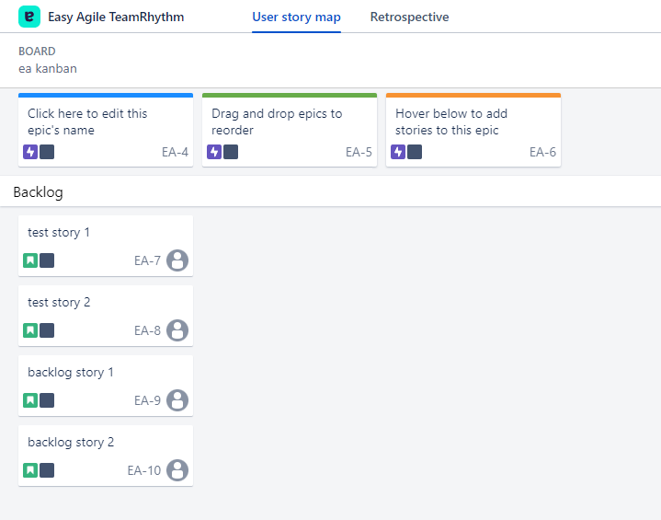

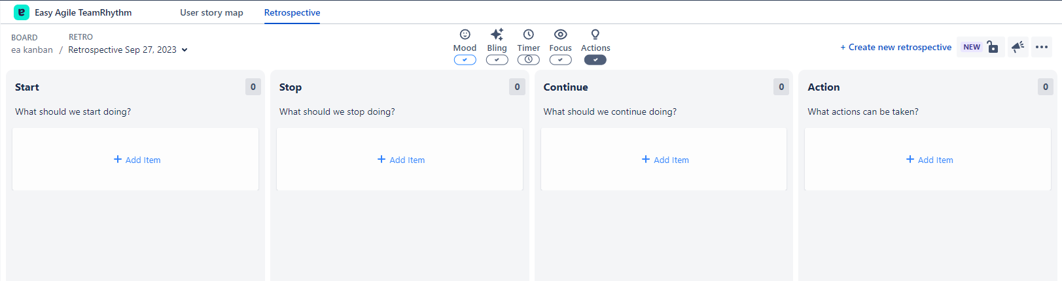

### 5.3.7 UpRaise for Employee Success Data Migration

There is no default migration pathway to merge. Migration will be done by manually recreating the dashboard and the form that has been used in BOS.

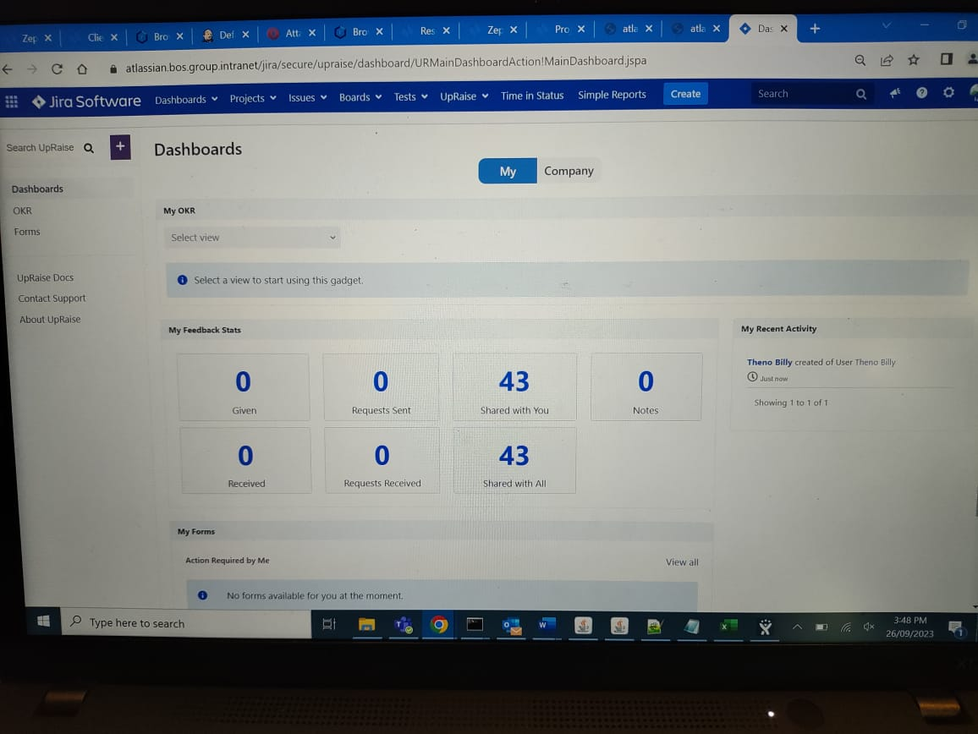

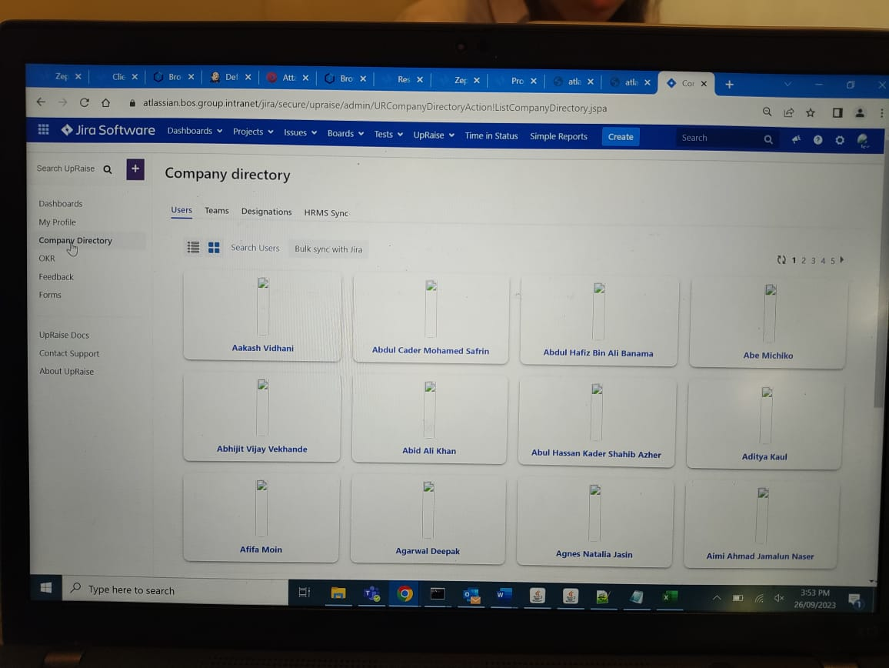

## 5.4 Rollback procedure

To do the rollback because the project is merging there will be no significant changes in the target so we just delete the project that we migrate in the production.

If need the clean instance without any data from BOS migrated, OCBC need to take database backup and file system backup

1. Shutdown the OCBC Jira Service
2. Restore the OCBC Database backup
3. Restore the OCBC Application Folder Backup from Jira Home
4. Turn on the OCBC Jira Service Up

# 

# 6. Nexus Migration Process

Objective is to migrate Nexus repositories from the BOS environment into the OCBC environment. Doing so enables:

* Optimisation of data management, and cleanup of old repositories, unused artifacts.
* High level visibility and traceability of data repositories across the Bank environment.

## 6.1 Prerequisites

To get started, the following prerequisites need to be met:

* BOS to be on Nexus instance with Pro license
* Prerequisite to transfer exported files* :
  + Upgrade BOS disk space to accommodate partition
  + Sufficient available disk space between BOS Nexus server and OCBC Nexus server. Need a minimum of 6.1 TB free disk space because when export need to have additional storage to keep the export result and if we use this method, we need space to partition the exported result.
  + Method - CIF Share with Partition
    - Stable network connection between BOS Nexus server and OCBC Nexus server. network bandwidth of 1 Gbps would be recommended.

## 6.2 Migration Procedure

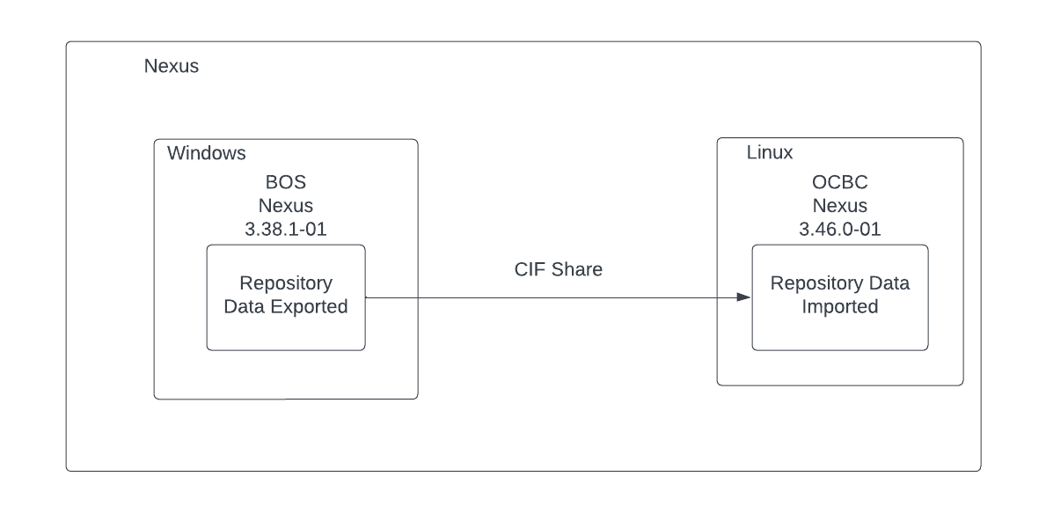

The exported data and imported data will be all the data inside the BOS repository that will be migrated.

### 6.2.1 Pre-Migration Procedure

* List repositories information in BOS Nexus using python script, including the configuration for each repository. This list will provide the following information about each repository: name, size, assets, checksum, and last modified.
* List the repositories name in OCBC Nexus.
* Check for conflicts in the repository name and asset name between BOS instance and OCBC instance.
* List the assets in OCBC Nexus using python script, from the repository that are the same as BOS Nexus.
  + If the asset has the same repository, name and path, BOS and OCBC team will need to resolve the asset name.
* Based on the repository size information, the BOS and OCBC teams will provide a sufficient disk size for the exported repository. Will need to provision a minimum of 6.1 TB free disk space in BOS VM instance.
* Blast email to all BOS Nexus users to not use BOS Nexus during the production migration and to confirm it is their risk to migrate during the production migration period.

Below is the list of BOS Nexus repository information that will be migrated.

|  |  |  |  |  |
| --- | --- | --- | --- | --- |
| Repo Name | Repo Format | Repo Type | URL | Size (GB) |
| docker-bosprivate | docker | hosted | <https://build.bos.group.intranet/nexus/repository/docker-bosprivate> | 198.8304545 |
| t24-migration | maven2 | hosted | <https://build.bos.group.intranet/nexus/repository/t24-migration> | 0.000259933 |
| releases-comlib | maven2 | hosted | <https://build.bos.group.intranet/nexus/repository/releases-comlib> | 0 |
| nuget-hosted | nuget | hosted | <https://build.bos.group.intranet/nexus/repository/nuget-hosted> | 0 |
| maven-central-extras | maven2 | hosted | <https://build.bos.group.intranet/nexus/repository/maven-central-extras> | 0.002160919 |
| uat-releases | maven2 | hosted | <https://build.bos.group.intranet/nexus/repository/uat-releases> | 206.2144387 |
| devRegistry | docker | hosted | <https://build.bos.group.intranet/nexus/repository/devRegistry> | 241.6871722 |
| maven-releases | maven2 | hosted | <https://build.bos.group.intranet/nexus/repository/maven-releases> | 0.745612792 |
| helm_repo | helm | hosted | <https://build.bos.group.intranet/nexus/repository/helm_repo> | 0.001 |
| thirdparty | maven2 | hosted | <https://build.bos.group.intranet/nexus/repository/thirdparty> | 1.236920368 |
| t24-libs | maven2 | hosted | <https://build.bos.group.intranet/nexus/repository/t24-libs> | 6.666812252 |
| releases | maven2 | hosted | <https://build.bos.group.intranet/nexus/repository/releases> | 2136.168267 |
| snapshots | maven2 | hosted | <https://build.bos.group.intranet/nexus/repository/snapshots> | 144.0856878 |
| prod-releases | maven2 | hosted | <https://build.bos.group.intranet/nexus/repository/prod-releases> | 116.6298202 |
| npm-storybook | raw | hosted | <https://build.bos.group.intranet/nexus/repository/npm-storybook> | 0.027744515 |
| npm-private | npm | hosted | <https://build.bos.group.intranet/nexus/repository/npm-private> | 1.741206202 |

.

Below is the list of conflicting repositories in BOS Nexus, which is the same as OCBC Nexus.

|  |  |  |
| --- | --- | --- |
| Repository | Format | Type |
| devRegistry | docker | hosted |
| docker-bosprivate | docker | hosted |
| helm_repo | helm | hosted |
| maven-central-extras | maven2 | hosted |
| maven-releases | maven2 | hosted |
| npm-private | npm | hosted |
| npm-storybook | raw | hosted |
| prod-releases | maven2 | hosted |
| releases | maven2 | hosted |
| releases-comlib | maven2 | hosted |
| snapshots | maven2 | hosted |
| t24-libs | maven2 | hosted |
| t24-migration | maven2 | hosted |
| thirdparty | maven2 | hosted |
| uat-releases | maven2 | hosted |

### 6.2.2 Migration Procedure

1. Create Nexus Export Task in BOS Nexus

You will need to

* Log into BOS Nexus as **Administrator.**
* Click the **Server Admin** button**.**

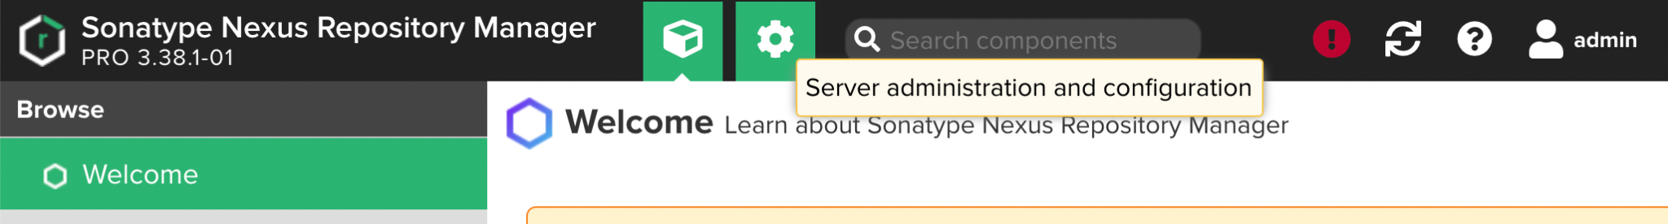

* On the left panel, click on **Tasks** under **System** section.

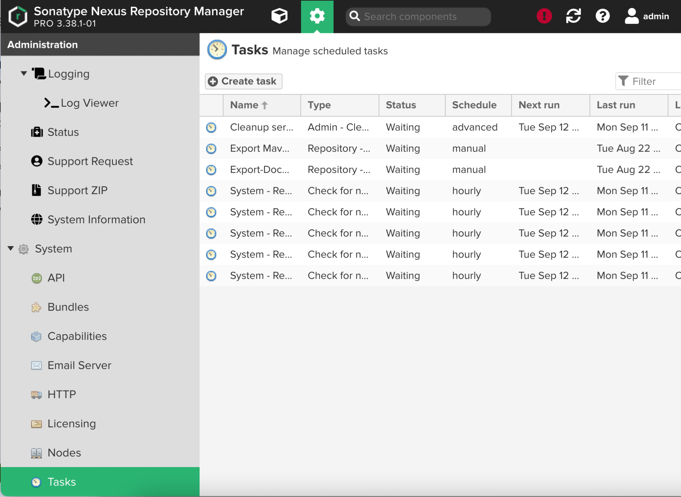

* Create a new task of type **Repository - Export assets.**

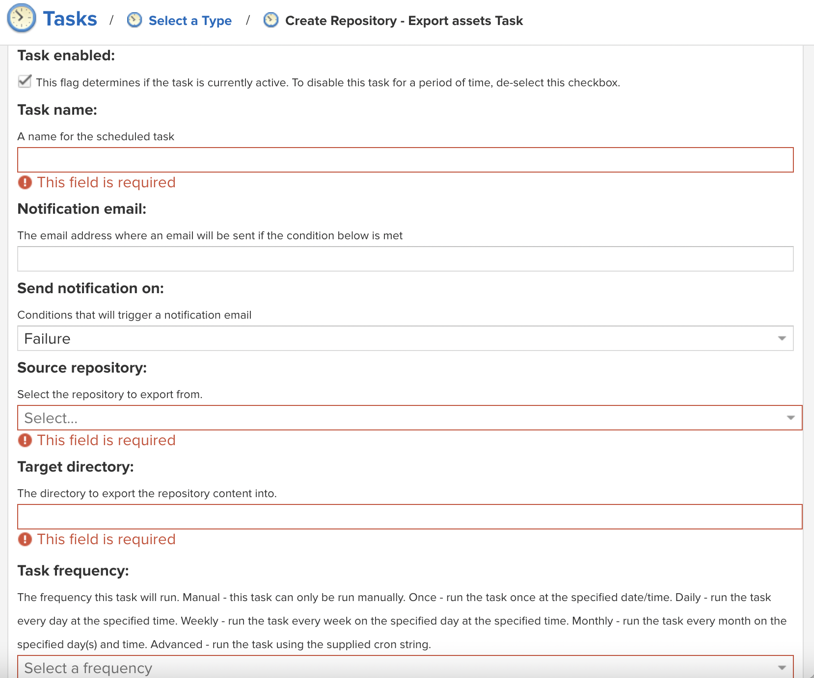

* Input a **Task name** to identify the task in user interface and log files.
* Configure a **Notification email** for the task execution. If the notification condition is met, a notification email will be sent to the configured email recipient.
* Notification can be sent on *Failure* or on *Success or Failure.*
* **Source repository** refers to the repository to export data from.
* **Target directory** refers to the directory in your server to export repositories into. The target directory must be writable by the user running the export task.
* Selecting the **Task frequency** allows you to configure the schedule for the task execution. Apart from *Manual* option, other options will trigger display of a custom user interface for scheduling the specific recurrence.
* Click **Create task** once done.
* On the Tasks interface, you can view the *status* and *last result* of the tasks.

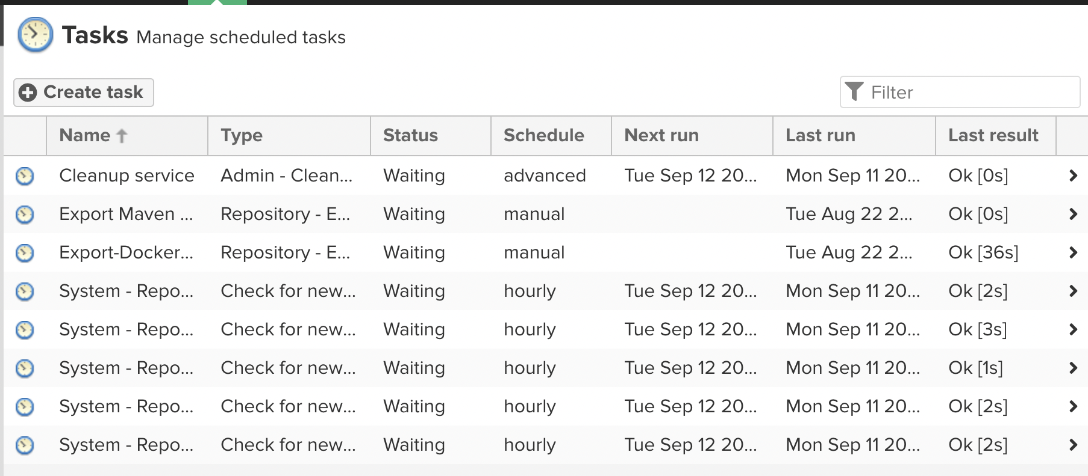

1. Run Nexus Export task in BOS Nexus

Only one export task can run at a time. When the task runs, it generates a *.nexus* directory inside of the target directory, that contains some metadata you can use for future exports. This enables you to keep exporting content into this directory, and each time only the newer content will be exported.

As the export is running, every single exported file will be logged to a *task log,* along with any errors that may have occurred. If an error occurs with any particular asset, this will be logged and the export process will continue.

1. Transfer the exported BOS Nexus data to OCBC Nexus

To transfer all the exported BOS Nexus data to OCBC server, this will be done via CIF Share method.

* From the Nexus Export task in step 2 above, put the exported BOS Nexus data in the newly provisioned disk space.
* Create a mount on the OCBC Linux VM that points to the BOS newly provisioned disk space.

1. Create new repositories in OCBC Nexus if no repository shares the same name as those in BOS Nexus

You will need to

* Log into OCBC Nexus as **Administrator**.
* Navigate to the **Repositories** page**.**
* Click **create repository.**
* Select the **Recipe** for the new repository. The Recipe combines the format and the type of repository.

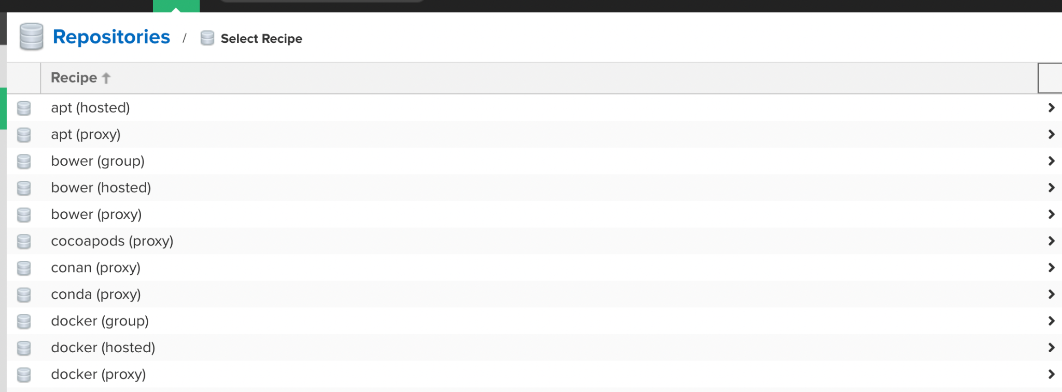

* The next page will show the configuration view that allows you to fill in the required parameters and further configuration. The exact view depends on the selected repository provider.

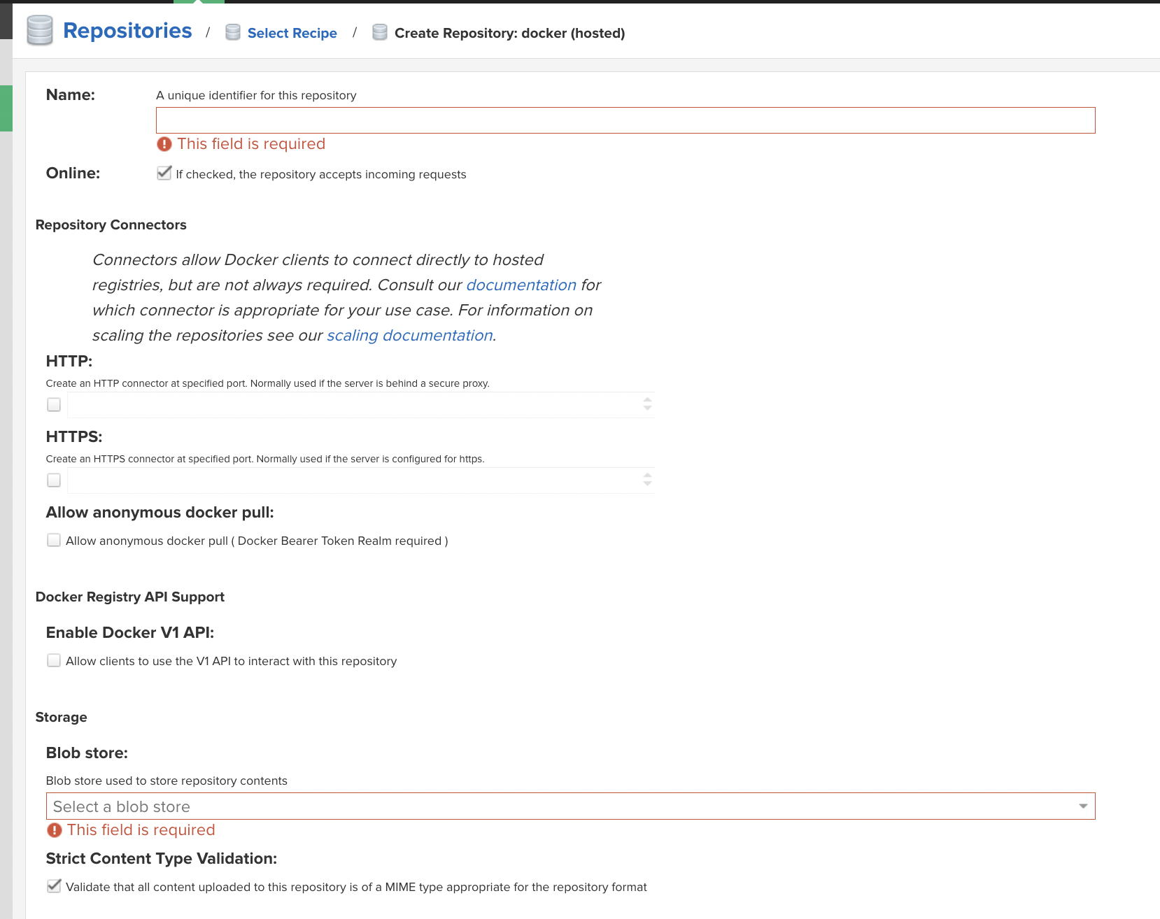

* Click **create** once done.

1. Create Nexus Import task in OCBC Nexus

Run Nexus Import task, referring to the path of the newly mounted file system

You will need to

* Log into OCBC Nexus as **Administrator.**
* Click the **Server Admin** button**.**
* On the left panel, click on **Tasks** under **System** section.
* Create a new task of type **Repository - Import external files.**

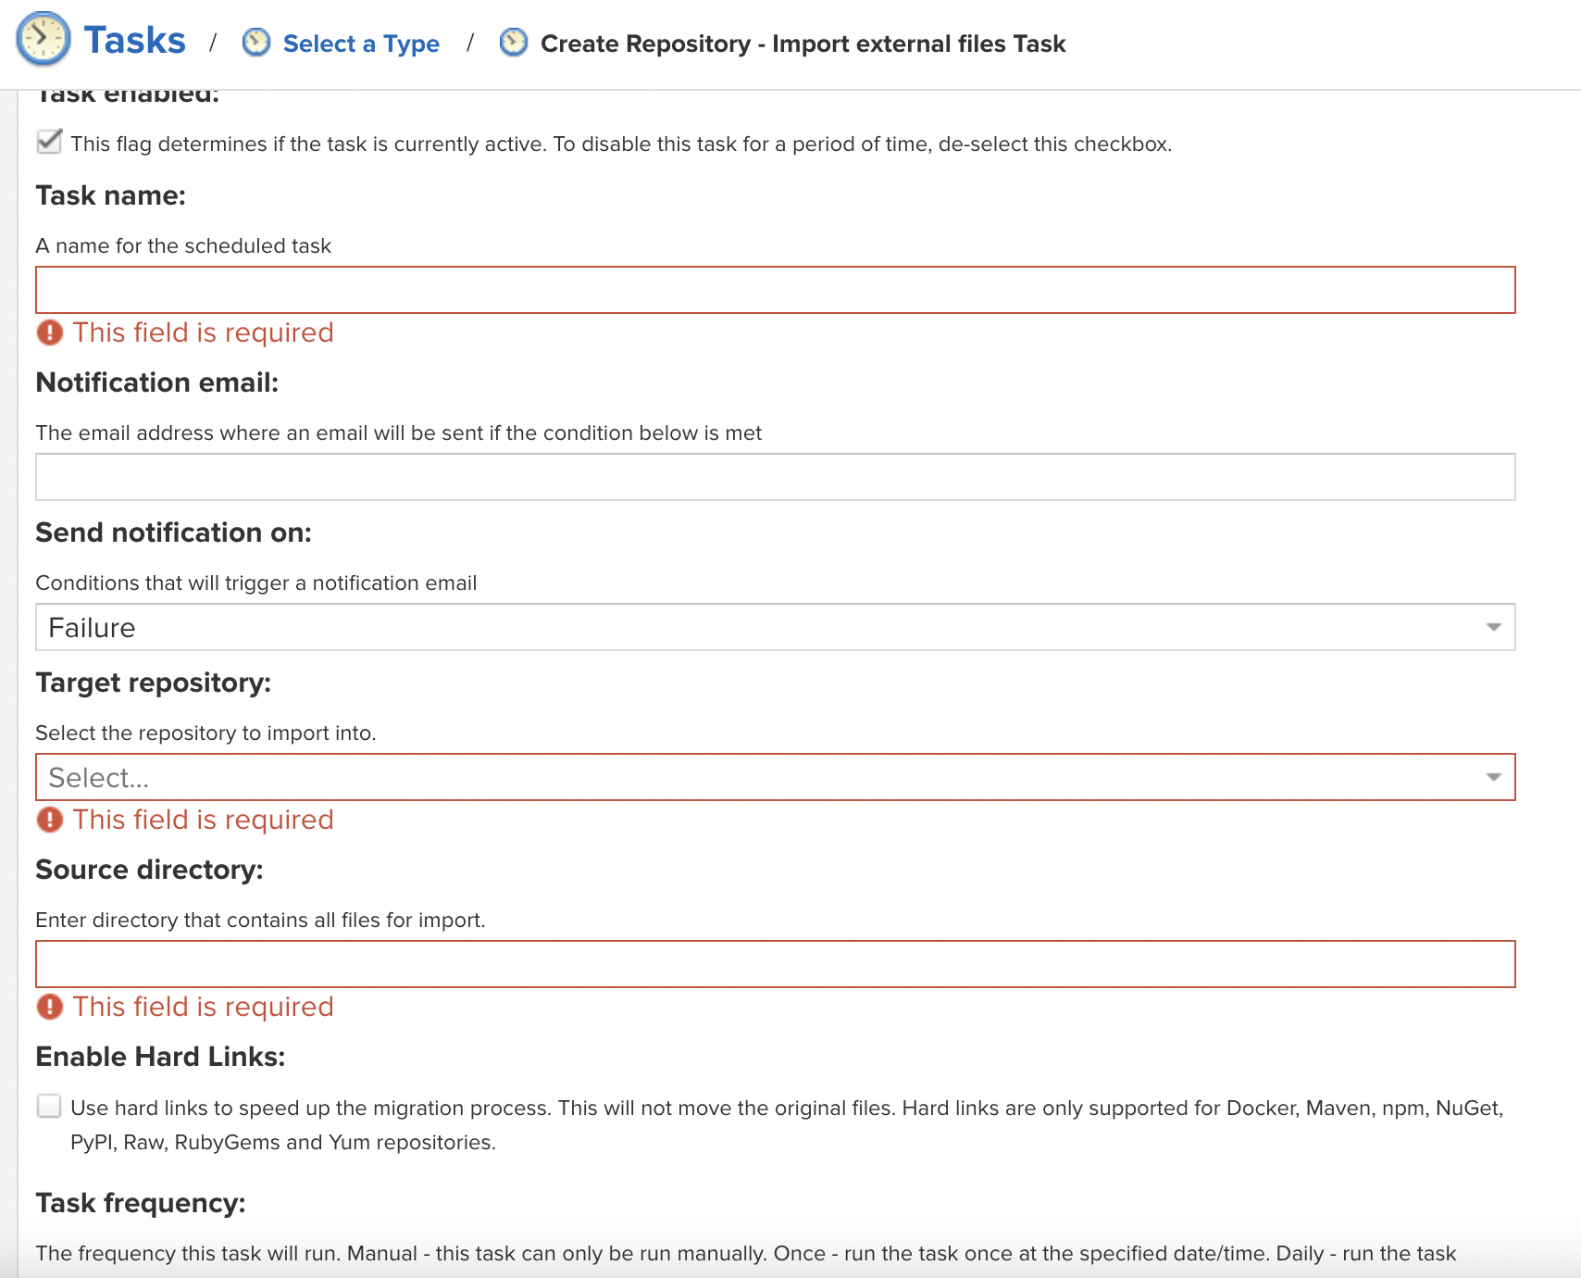

* Input a **Task name** to identify the task in user interface and log files.
* Configure a **Notification email** for the task execution. If the notification condition is met, a notification email will be sent to the configured email recipient.
* Notification can be sent on *Failure* or on *Success or Failure.*
* **Target repository** refers to the repository into which to import data.
* **Source directory** refers to the directory from which to import data.
* The **Enable Hard Links** option will create hard links for the blobs in the source directory to be used in the target directory. A physical copy of the blobs will not be created in the target directory.
* Selecting the **Task frequency** allows you to configure the schedule for the task execution. Apart from *Manual* option, other options will trigger display of a custom user interface for scheduling the specific recurrence.
* Click **Create task** once done.
* On the Tasks interface, you can view the *status* and *last result* of the tasks.

1. Run Nexus Import task in OCBC Nexus

Only one import task can run at a time. When the task runs, it generates a *.nexus/nxrm-export-import-task/* directory inside the source directory that contains metadata you can use for future imports. This enables you to keep placing content into this directory and each time only importing newer content.

As the import is running, every single imported file will be logged to a *task log,* along with any errors that may have occurred. If an error occurs with any particular file, this will be logged and the import process will continue.

**Error Handling - Conflicting Repository Name** -

If the repository name is the same, the new item will be appended. If the repository name and asset name are the same, the item in the target repository will be replaced with the item from the source repository. To resolve conflicts with items, the workaround is to either rename the source asset or change the tagging.

### 6.2.3 Post-migration Procedure

* List all the new Nexus repository information in OCBC using python script, including the configuration for each repository. This list will provide the following information about each repository: name, size, assets, checksum, and last modified.
* List the new assets in OCBC Nexus from the repository that are the same as Nexus BOS, as well as the new repository that has been created in the migration process.
* Compare the list before and after the migration.

# 

# 7. Bitbucket Reconfiguration

Objective is to reconfigure Nexus URL in BOS Bitbucket repositories to use OCBC Nexus URL. Doing so enables:

* Integration of BOS Bitbucket with Nexus instance in OCBC.
* An integrated CI/CD solution that will allow continuous delivery.

Bitbucket Reconfiguration will be done as part of Nexus Post Migration.

## 7.1 Prerequisites

To get started, the following prerequisites need to be met:

* Local machines have to have Administrator access to BOS Bitbucket and BOS Jenkins.
* Require the following software installed in local machine or the jenkins agent:
  + Python 3

## 7.2 Configuration Steps

1. Create new repository in BOS Bitbucket

You will need to

* Log into BOS Bitbucket as **Administrator.**
* Click the **Create** button and select **Repository** from the dropdown list.

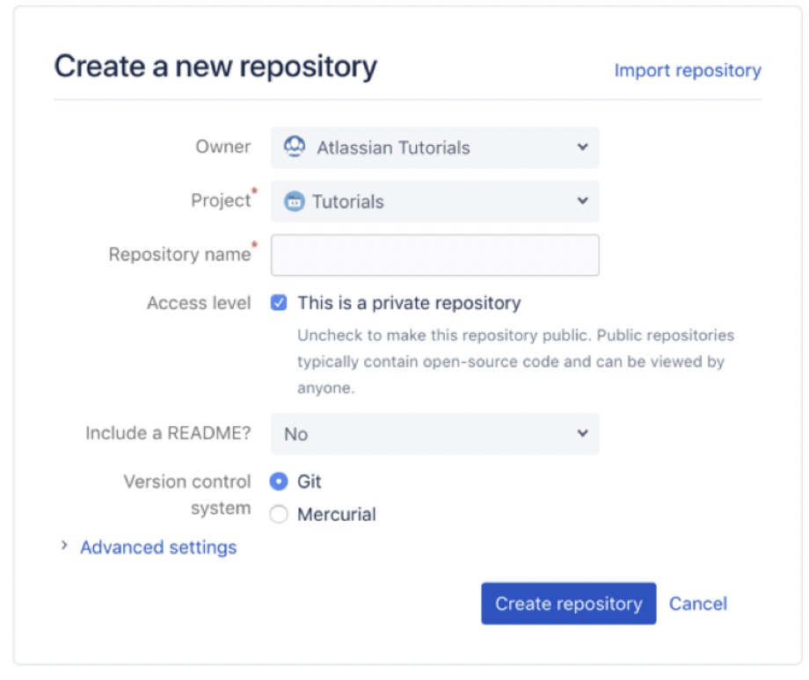

* In the Owner option, choose a repository **Workspace.**
* Select a project from the **Project** dropdown list.
* Input a **Repository name** to describe your repository. The repository name will be included in its URL.
* Keep access to your repository set to **Private,** unless you wish to make your repository public to others.
* Select **No** from **Include a README** option if you already have files you wish to add to your repository. Otherwise, go with the default option or select an option from the dropdown list.
* Select the **Version control system**, or keep **Git** as the default.
* Click **Create repository**.

1. Clone this new repository to your local machine

You will need to

* From the repository, select the **Clone** button on the left menu.

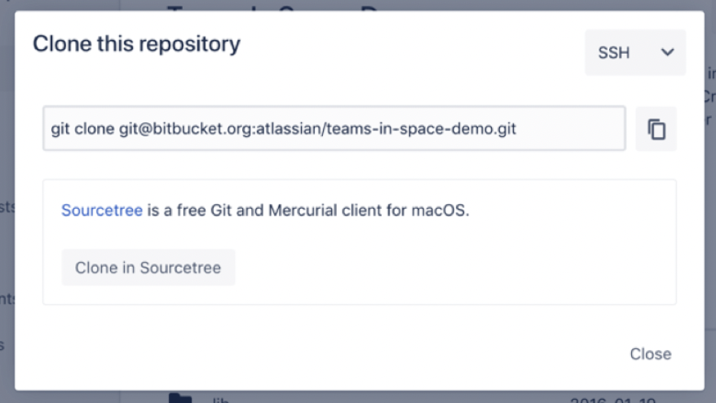

* From the drop-down on the top right, select either **SSH** or **HTTPS**. If you are using the SSH protocol, ensure your public key is in Bitbucket and available on the local machine to which you are cloning.
* **Copy** the clone command
* On your local machine, open the **Command Prompt** application.
* From the terminal window, change to the local directory where you wish to clone the repository, using the ***cd* command**.
* Paste the command you copied from Bitbucket.

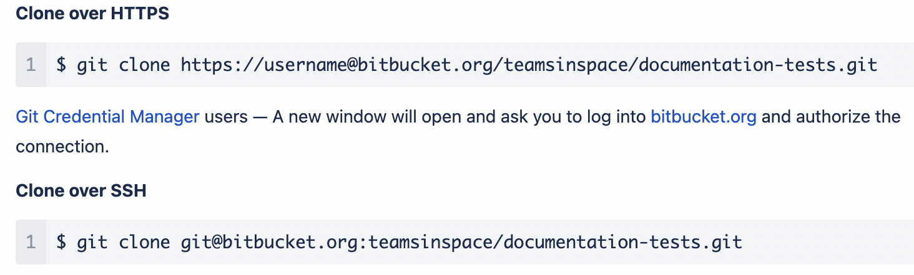

* Upon successful clone, a new sub-directory will appear in your local drive in the directory where you cloned the repository. This directory has the same name as the Bitbucket repository that you cloned. The clone contains the files and metadata that Git requires to maintain the changes you make to the source files.

1. Add the Python scripts to your local repository

You will need to

* Move the script files into the local directory that was created when you cloned the repository.
  + *BitbucketMigrationScipt.py*
* From the command terminal window, change to your local repository, using the ***cd* command**.
* **Stage** the script files for commit to your local repository. You can use *“git add --all”* command to add all the files.

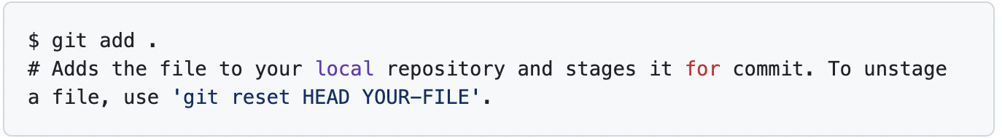

* **Commit** the script files

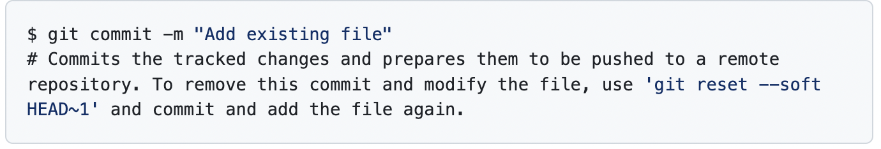

1. Add the Jenkins File to your local repository

You will need to

* Move the Jenkin File into the local directory that was created when you cloned the repository.
  + *Jenkinsfile*
* From the command terminal window, change to your local repository, using the ***cd* command**.
* **Stage** the Jenkin File for commit to your local repository.



* **Commit** the Jenkin File.



1. Push changes made on local repository to BOS Bitbucket

You will need to

* Have **write access** to the particular repository in BOS Bitbucket.
* From the command terminal window, change to the particular repository directory you wish to push changes to.
* Use **git push** command to push commits from your local repository to BOS Bitbucket

*git push <remote_server> <branch_name>*

where

* *remote_server* is the name of the remote server. *origin* indicates you are pushing to Bitbucket.
* *branch_name* is the repository branch where you made your changes and wish to push them.
* If prompted for authentication, enter your Bitbucket username and password.
* Once complete, open the BOS Bitbucket repository in your browser. The Commit tab shows your most recent commits.

1. Trigger the job via BOS Jenkins

You will need to:

* Log into BOS Jenkins as **administrator**.
* At the Dashboard page, on the top left click **New Item**.

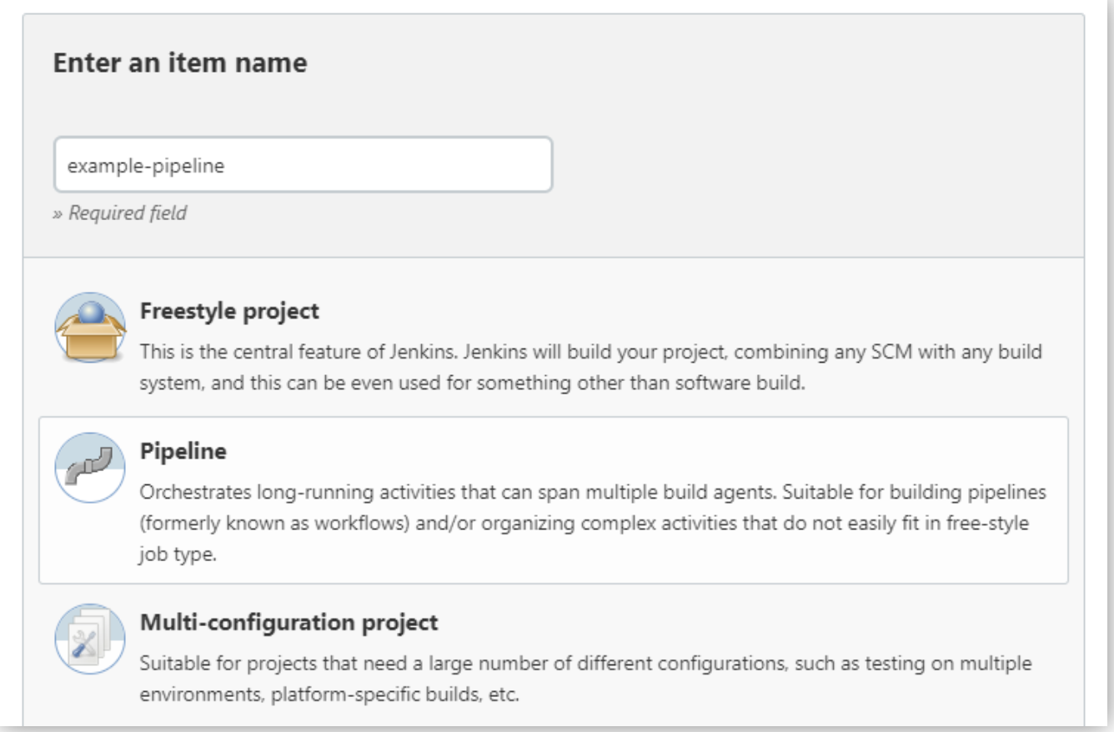

* Specify the name for your Pipeline. Note Jenkins uses this item name to create directories on disk, hence recommended to avoid using spaces in name.
* Select **Pipeline,** then click **OK** at the end of the window to trigger the opening of the Pipeline configuration page.

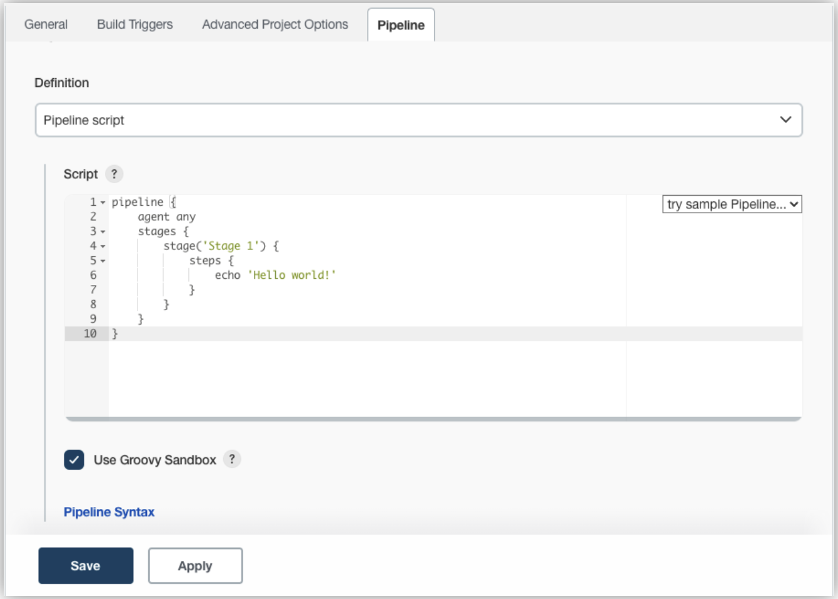

* Click the **Pipeline** tab.
* In the **Definition** field, choose the **Pipeline script from the SCM** option.
* In the **SCM** field, choose the type of source control system of the repository containing your Jenkins File.
* Complete the fields specific to your repository’s source control system.
* In the **Script Path** field, specify the location and name of your Jenkins File. This location is where Jenkins will check out/clone the repository containing your Jenkins File.
* Click **Save** to open the Pipeline item view page.
* On this page, click **Build Now** on the left to run the Pipeline.
* Under **Build History** on the left, click **#1** to access the details of the Pipeline run.
* Click **Console Output** to see the full output from the Pipeline run.

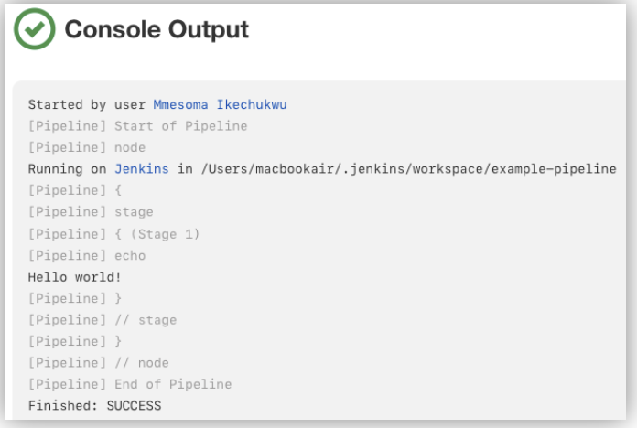

1. Validate the changes in BOS Bitbucket

You will need to:

* Log into BOS Bitbucket as **Administrator.**
* Navigate to the Repositories page to see the latest status of the repositories.
* Open your Repository and click on the Commitstab to see the latest changes made.

# 8. Jenkins Reconfiguration

Objective is to reconfigure Nexus URL in BOS Jenkins instance to use OCBC Nexus URL. Doing so enables:

* Integration of BOS Jenkins with Nexus instance in OCBC.
* An integrated CI/CD solution that will allow continuous delivery.

Jenkins Reconfiguration will be done as part of Nexus Post Migration.

## 8.1 Prerequisites

To get started, the following prerequisites need to be met:

* Local machines have to have Administrator access to BOS Jenkins and BOS Bitbucket.
* Require the following software installed in local machine and BOS Jenkins server:
  + Python 3

## 8.2 Configuration Steps

1. Add the Python scripts to your local repository

In Section 7.2 above, you have created and cloned a repository from BOS Bitbucket instance to your local directory, refer to Step 1 and 2. You may use the same local directory to store the python scripts for this section.

You will need to:

* Move the script files into the local directory that was created when you cloned the repository.
  + *file-list.py*
* From the command terminal window, change to your local repository, using the ***cd* command**.
* **Stage** the script files for commit to your local repository. You can use the *“git add --all”* command to add all the files.



* **Commit** the script files



1. Add the Jenkinsfile to the pipeline configuration

You will need to

* Move the Jenkinsfile into the local directory that was created when you cloned the repository.
  + *Jenkinsfile*
* From the command terminal window, change to your local repository, using the ***cd* command**.
* **Stage** the Jenkin File for commit to your local repository.



* **Commit** the Jenkin File.



1. Push changes made on local repository to BOS Bitbucket

You will need to

* Have **write access** to the particular repository in BOS Bitbucket.
* From the command terminal window, change to the particular repository directory you wish to push changes to.
* Use **git push** command to push commits from your local repository to BOS Bitbucket

*git push <remote_server> <branch_name>*

where

* *remote_server* is the name of the remote server. *origin* indicates you are pushing to Bitbucket.
* *branch_name* is the repository branch where you made your changes and wish to push them.
* If prompted for authentication, enter your Bitbucket username and password.
* Once complete, open the BOS Bitbucket repository in your browser. The Commit tab shows your most recent commits.

1. Trigger the job via BOS Jenkins

You will need to:

* Log into BOS Jenkins as **administrator**.
* At the Dashboard page, on the top left click **New Item**.



* Specify the name for your Pipeline. Note Jenkins uses this item name to create directories on disk, hence recommended to avoid using spaces in name.
* Select **Pipeline,** then click **OK** at the end of the window to trigger the open of Pipeline configuration page.
* Click the **Pipeline** tab.
* In the **Definition** field, choose the **Pipeline script from SCM** option.
* In the **SCM** field, choose git.
* Complete the fields specific to your repository’s source control system.

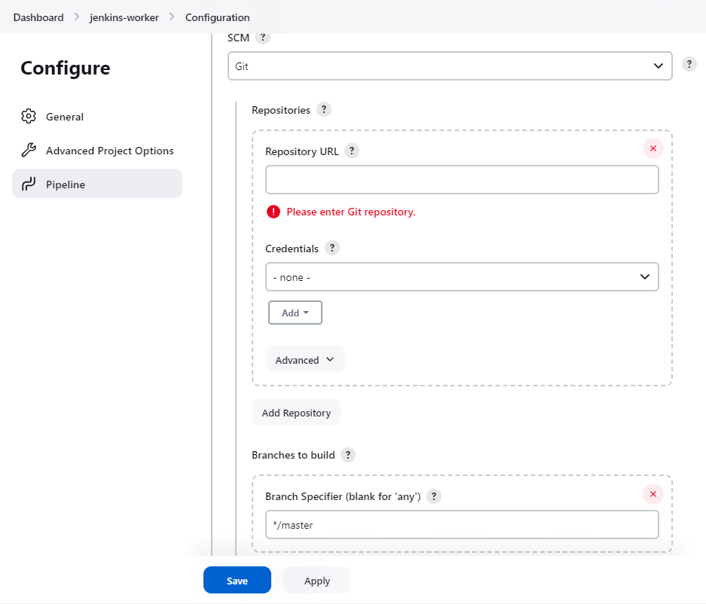

* In the **Script Path** field, specify the location and name of your Jenkinsfile..
* Click **Save** to open the Pipeline item view page.
* On this page, click **Build Now** on the left to run the Pipeline.
* Under **Build History** on the left, click **#1** to access the details of the Pipeline run.
* Click **Console Output** to see the full output from the Pipeline run.

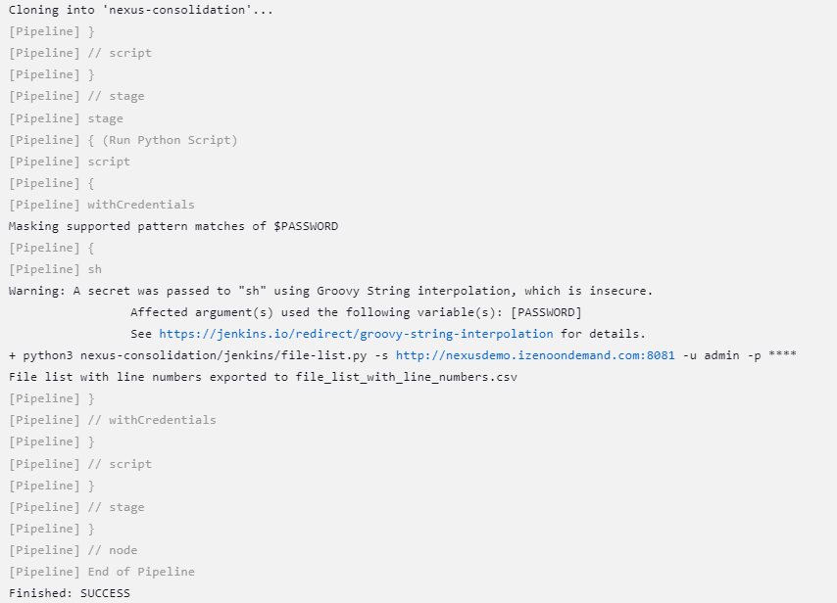

1. Validate the changes in BOS Jenkins

You will need to:

* Log into BOS Jenkins as **Administrator.**
* Navigate to the Dashboard page.
* Click on **Build History** to see past builds and status of each build.
* Select **Console Output** to see details of the build output.

1. Get the csv file from Jenkins

* Log into BOS Jenkins as **Administrator.**
* Navigate to the Dashboard page.
* Click on the latest build from **Build History**
* Go to **Workspaces** and select the path

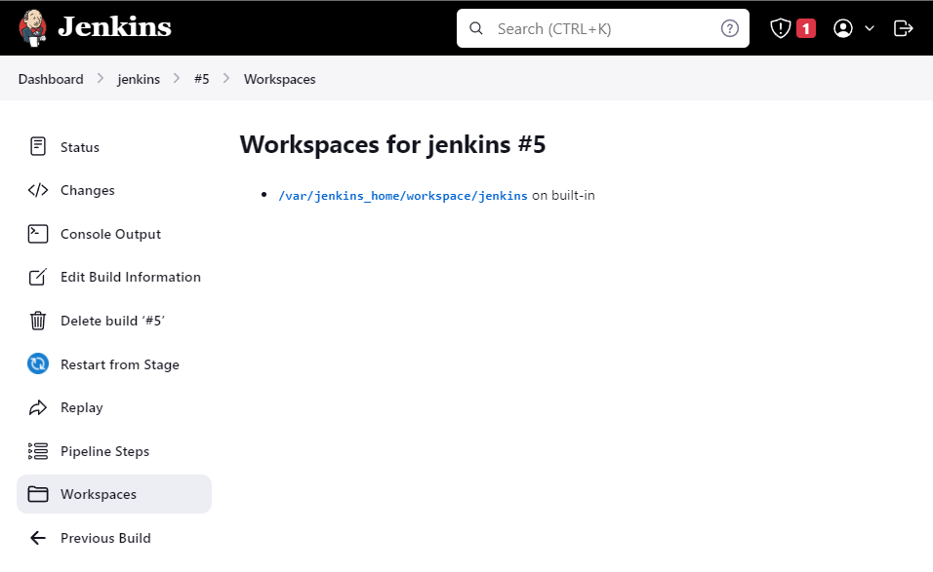

* Download the csv file

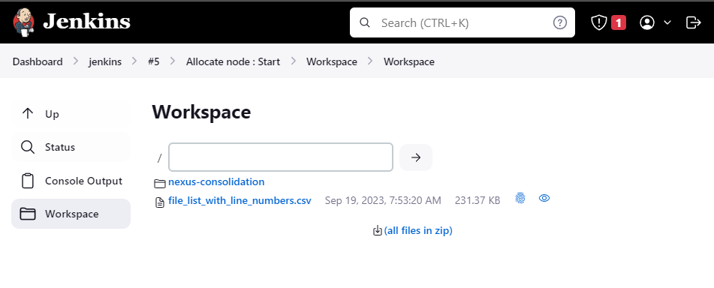

1. Change the Nexus URL in files based on the provided csv from the BOS to OCBC

# 

# 9. Migration Runbook Schedule

The below table shows the rough downtime required for executing the migration for each of the task items in our scope of work.

|  |  |  |
| --- | --- | --- |
| DevOps Tool | Task | Rough Downtime required |
| Jira | Migration of BOS Jira project data and Add-on data to OCBC Jira | 2 - 3 days |
| Nexus | Migration of BOS Nexus repository data to OCBC Nexus | 4 - 5 days |
| Bitbucket | Reconfigure Nexus URL in BOS Bitbucket to use OCBC Nexus URL | 3 - 4 days |
| Jenkins | Reconfigure Nexus URL in BOS Jenkins to use OCBC Nexus URL | 2 - 3 days |